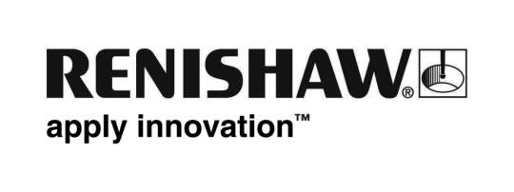
February 2018 Enquiries: Chris Pockett, Head of Communications (+44 1453 524133)

Renishaw funds £10,000 Super Science prize

For the third year running, global engineering technologies company, Renishaw, teamed up with The Bristol Post to sponsor the newspaper’s Super Science competition. In January 2018, Renishaw presented the £10,000 prize to the winning school, Hareclive Academy. The prize money will be used to deliver outstanding science education to the school’s pupils, to develop their interest in science, technology, engineering and maths.

By collecting tokens that appeared daily in The Bristol Post, schools could increase their chances of winning the competition. In the Concorde Hangar in the new Aerospace Bristol museum, Lloyd Burnell, Chief Executive of Aerospace Bristol, randomly selected the winning school.

The winner, Bristol primary school, Hareclive Academy, will spend its winnings on developing new, engaging science curriculum. The school will also arrange science trips and install a space dome that will help Year Five pupils to learn about the universe.

In addition, Hareclive Academy is planning for its Year Five and Six pupils to visit Renishaw’s state-of-the-art Gloucestershire headquarters, to learn about engineering, its applications and its impact on their daily lives. During the visit, the students will build a liquid-crystal display (LCD) torch, a hands-on project designed to get young people excited and inspired.

“The UK has an annual shortage of around 20,000 engineers,” explained Chris Pockett, Head of Communications at Renishaw. “Research has shown that young people are far more likely to choose a career in science or engineering if they are interested at an early age. This means it’s important that primary school pupils have access to resources to help foster this interest.

“The money will make a huge difference to the school and allow us to introduce activities that will enrich our students’ learning, providing them with experiences they may not previously have had,” said Kate Richardson, Headteacher at Hareclive Academy.

Renishaw offers an extensive education outreach programme across Bristol, Gloucestershire and South Wales. The company works with primary and secondary schools as well as universities to help young people develop an interest in engineering.

For more information about Renishaw’s education outreach programme or to book a visit online, visit http://www.renishaw.com/education-outreach.

Ends 349 words
Notes to editors
UK-based Renishaw is a world leading engineering technologies company, supplying products used for applications as diverse as jet engine and wind turbine manufacture, through to dentistry and brain surgery. It has over 4,000 employees located in the 35 countries where it has wholly owned subsidiary operations.

For the year ended June 2017 Renishaw recorded sales of £536.8 million of which 95% was due to exports. The company’s largest markets are China, the USA, Japan and Germany.

Throughout its history Renishaw has made a significant commitment to research and development, with historically between 14 and 18% of annual sales invested in R&D and engineering. The majority of this R&D and manufacturing of the company’s products is carried out in the UK.

The Company’s success has been recognised with numerous international awards, including eighteen Queen’s Awards recognising achievements in technology, export and innovation.

Further information at www.renishaw.com

