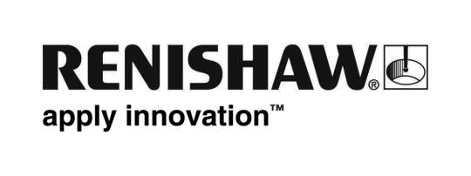
August 2018 Enquiries: Chris Pockett, Head of Communications (+44 1453 524133)

Renishaw work experience inspires future apprentices
After several years of hosting its popular engineering work experience programme, Gloucestershire-based engineering technologies company Renishaw has seen an increase in applications for its engineering apprenticeship schemes. In summer 2018, the company hosted its work experience weeks for a new cohort of 117 students aged 15 to 17.

During the event, the pupils from schools local to the Renishaw headquarters site attended to gain an insight into engineering. A total of 96 students participated in the engineering work experience programme and 21 students took part in a dedicated software engineering work experience week. The engineering students were given a project brief, working in teams to create a business plan and concept model of a product by the end of the week and the software students were asked to work on a coding project. As a conclusion to the week all students presented their work to senior management.

New this year was the inclusion of some job shadowing, so each student was given the opportunity to shadow a Renishaw employee who was carrying out the same role that they had chosen within their team; this was to give the students more of an insight into their day-to-day role.

“The work experience weeks are a great opportunity for young people in the area to find out what an engineering career is really like,” explained Siobhan Denniff, Education Outreach Executive at Renishaw. “The projects are modelled on the way Renishaw operates, which is why it’s great to see so many work experience attendees apply for our apprenticeships.

“At this year’s apprenticeship assessment, 15 per cent of shortlisted applicants were from the work experience programme,” added Denniff. “This is extremely encouraging, particularly as we are seeing an increase in applicants to our software work experience scheme, which we expanded from 2017 and now plan to further increase next year.”

James Joynson, a second year Manufacturing Apprentice at Renishaw and previous work experience attendee was one of the team mentors this year and really enjoyed supporting the students throughout the week: “I have always had an interest in engineering,” explained Joynson. “During my own work experience week, I took on the role of Production Engineer in my team and was shown all of the facilities and equipment at Renishaw, and knew I wanted to become an apprentice one day.

“It’s been great so far, studying at college part-time and working in the machine shop,” added Joynson. “Work experience really opened my eyes to Renishaw and to engineering and I would recommend it to everyone!”

For more information on careers in engineering at Renishaw or how you can get involved in next year’s work experience, visit
www.renishaw.com/careers.

Ends 441 words
Notes to editors
UK-based Renishaw is a world leading engineering technologies company, supplying products used for applications as diverse as jet engine and wind turbine manufacture, through to dentistry and brain surgery. It has over 4,500 employees located in the 36 countries where it has wholly owned subsidiary operations.

For the year ended June 2018 Renishaw recorded sales of £611.5 million of which 95% was due to exports. The company’s largest markets are China, the USA, Germany and Japan.

Throughout its history Renishaw has made a significant commitment to research and development, with historically between 13 and 18% of annual sales invested in R&D and engineering. The majority of this R&D and manufacturing of the company’s products is carried out in the UK.

The Company’s success has been recognised with numerous international awards, including eighteen Queen’s Awards recognising achievements in technology, export and innovation.

Further information at http://www.renishaw.com/

