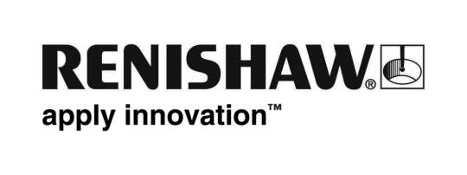
July 2018 Enquiries: Chris Pockett, Head of Communications (+44 1453 524133)

Renishaw to demonstrate its latest additive manufacturing solutions at IMTS

At the International Manufacturing Technology Show (IMTS), global engineering technologies company Renishaw will exhibit its additive manufacturing software and systems from a dedicated booth, in addition to its booth focused on metrology products. From September 10 - 15, 2018, McCormick Place, Chicago, USA, the company will showcase how it is advancing multi-laser technology to increase productivity in additive manufacturing. The company will also launch its new powder handling solution in collaboration with LPW Technology.

Renishaw's additive manufacturing stand can be found in the 3D printing and additive manufacturing zone, West building, level 3, stand 431607.

Renishaw will exhibit the recently launched multi-laser system, RenAM 500Q, which can improve AM productivity by up to four times without increasing platform size. The system will bring the benefits of additive manufacturing to a wider range of components. With competitive market positioning, the system will reduce the cost per part whilst revised gas flow to manage emissions from four lasers improves process consistency and part quality.

“Renishaw is helping companies to ramp up the production of their additive parts,” explained Stephen Anderson, Additive Manufacturing Business Manager at Renishaw Inc. “The technology is moving towards a mainstream serialised production technique for industrial environments, by speeding up the process by up to four times, improving productivity and decreasing cost per part.
The RenAM 500Q system also introduces intelligent gas flow technology to ensure the efficient removal of process emissions and extended filter life.

“This is emphasised by our use of the RenAM 500Q to produce a core part of the system's optical system. We have the utmost confidence in additive manufacturing and are working together with our customers to increase part quality, understanding and consistency.”

Renishaw will also launch a new external powder silo option for its RenAM 500 family of additive manufacturing (AM) systems. As standard, Renishaw AM systems feature integrated automated powder handling systems which enable consistent process quality, minimize operator intervention time and ensure high standards of system safety. However, for some companies established working methods require the ability to handle batch-to-batch powder management. To meet this need, Renishaw has collaborated with LPW Technology, to integrate its PowderTrace® hopper as an option. The hopper, designed exclusively for AM metal powders, is an ideal solution for users who require batch control on the Renishaw RenAM platform. The PowderTrace hoppers have a capacity of 120 litres and feature the PowderEye monitoring system.

For more information on Renishaw AM visit www.renishaw.com/additive.

Ends 361 words
Notes to editors
UK-based Renishaw is a world leading engineering technologies company, supplying products used for applications as diverse as jet engine and wind turbine manufacture, through to dentistry and brain surgery. It has over 4,500 employees located in the 35 countries where it has wholly owned subsidiary operations.

For the year ended June 2017 Renishaw recorded sales of £536.8 million of which 95% was due to exports. The company’s largest markets are China, the USA, Japan and Germany.

Throughout its history Renishaw has made a significant commitment to research and development, with historically between 14 and 18% of annual sales invested in R&D and engineering. The majority of this R&D and manufacturing of the company’s products is carried out in the UK.

The Company’s success has been recognised with numerous international awards, including eighteen Queen’s Awards recognising achievements in technology, export and innovation.

Further information at www.renishaw.com

