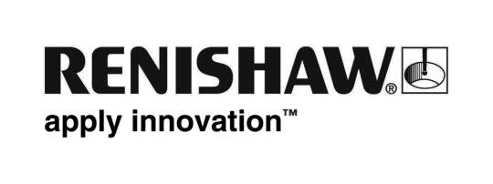
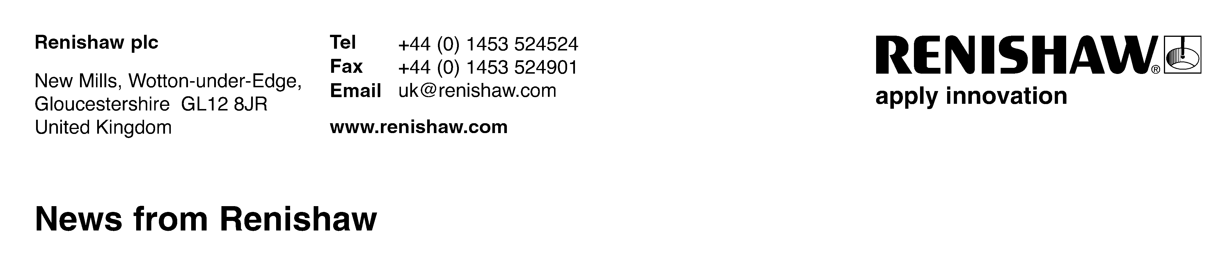
28 September 2016 Enquiries: Chris Pockett, Head of Communications (+44 1453 524133)

Renishaw encourages industry collaboration at PraxisUnico research contracts event

Global engineering firm Renishaw shared its experience of managing collaborative research partnerships by delivering two sessions at PraxisUnico's Research Contracts conference 2016, which took place between September 13-16th, at the Marriott Hotel in Peterborough, UK. At the event, one of Renishaw's in house legal team described best practice for using model research agreements and ran a workshop on drafting contracts with industrial sponsors.

PraxisUnico supports knowledge exchange and commercialisation (KEC) in the UK, facilitating collaboration between universities, research institutes, government organisations and companies from a variety of industrial sectors.

The Research Contracts course helped university contracts professionals gain the skills required for a successful research contract negotiation. This included setting objectives and developing influencing skills, as well as offering specific technical and legal knowledge.

Nikki Powell, a solicitor and commercial lawyer at Renishaw, delivered the training sessions focussing on making the research contracts agreement process work more effectively for all parties. This included legal guidance and advice about where to find helpful resources, such as the Government's Lambert toolkit.

"Creating and managing collaborative relationships between organisations can often prove challenging," explained Powell. "Intellectual property, confidentiality and how to achieve the parties’ overall aims and objectives can be sensitive subjects that need to be agreed upon at the start of a project. However, the rewards of successful partnerships far outweigh initial difficulties. Research collaborations between universities and engineering companies are creating some really innovative developments in the UK today.

"Renishaw regularly collaborates on projects with multiple partners. Part of our overall success as a business is down to these relationships. By helping other organisations embark on joint research projects, we hope to continue the UK's reputation as an innovative manufacturing nation."

Renishaw is a partner of a project that recently won a Collaborate to Innovate award in the Health and Wellbeing category. Additive-manufacture for Design-led Efficient Patient Treatment (ADEPT) is a joint venture between four organisations from academia and industry to revolutionise maxillofacial implants through design and laser melting.

For further information about Renishaw, go to www.renishaw.com.

Ends 336 words
Notes to editors
UK-based Renishaw is a world leading engineering technologies company, supplying products used for applications as diverse as jet engine and wind turbine manufacture, through to dentistry and brain surgery. It has over 4,000 employees located in the 35 countries where it has wholly owned subsidiary operations.

For the year ended June 2016 Renishaw recorded sales of £436.6 million of which 95% was due to exports. The company’s largest markets are China, the USA, Japan and Germany.

Throughout its history Renishaw has made a significant commitment to research and development, with historically between 14 and 18% of annual sales invested in R&D and engineering. The majority of this R&D and manufacturing of the company’s products is carried out in the UK.

The Company’s success has been recognised with numerous international awards, including eighteen Queen’s Awards recognising achievements in technology, export and innovation.

Renishaw is listed on the London Stock Exchange (LSE:RSW) where it is a constituent of the FTSE 250, with a current valuation of around £1.8 billion.

Further information at www.renishaw.com

