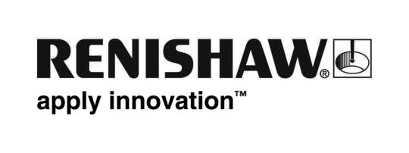
June 2018 Enquiries: Chris Pockett, Head of Communications (+44 1453 524133)

Renishaw launches free 3D printer loan scheme for schools
Global engineering company Renishaw has purchased ten 3D printers to loan to primary and secondary schools in South Wales as part of a free scheme. As well as the printer itself, schools will receive hands on training from Renishaw on how to use a 3D printer. The project will be rolled out in September 2018 to help engage and inspire the next generation of engineers in a fun and educational way.

Each school will have access to a 3D printer for a period of up to three months. During this time, Simon Biggs, Education Outreach Officer at Renishaw, will train the pupils and teachers on how to use the printers to support the school curriculum, either at the school or at Renishaw’s Fabrication Development Centre (FDC) in Miskin, South Wales. The schools will also receive downloadable training resources from CREATE Education Project — an organisation that provides free resources and support to help educators introduce and embed 3D printing technology in the classroom.

“The manufacturing industry is really starting to see the benefits of 3D printing and it looks like the technology will be a fundamental part of engineering in the future,” explained Biggs. “3D printing is also a fantastic classroom resource because it allows pupils to easily create physical versions of their ideas, which teaches them about design and manufacturing principles.

“The majority of schools don’t have access to a 3D printer or lack the skills needed to make the most of the technology,” continued Biggs. “Renishaw’s 3D printer loan scheme will give students and teachers enriched classroom experiences and provide an exciting opportunity to learn more about engineering. We hope that more schools will educate and inspire their pupils with the technology.”

Renishaw’s training will introduce the schools to Tinkercad, a free computer-aided design (CAD) software developed by Autodesk to introduce pupils to CAD at a young age. The company will also explain how to 3D print the structures that the pupils design. This process enhances capabilities in design and technology (D&T) classes and can also bring benefits to other subjects across the curriculum, such as maths, geography and art.

Renishaw will loan schools a 3D printer that uses fused deposition modelling (FDM), commonly known as plastic 3D printing, using polylactic acid (PLA) plastic. The printers are robust and easy to use, capable of printing complex designs to illustrate teaching points as well as simple products designed by primary school pupils.

The project will begin in South Wales in September 2018 and will be rolled out to schools in Gloucestershire and Bristol in the future.

Renishaw has a well-established education outreach programme that helps to inspire the next generation of engineers. For more information about Renishaw’s education outreach programme and how you can get involved visit http://www.renishaw.com/educationoutreach.

Ends 459 words
Notes to editors
UK-based Renishaw is a world leading engineering technologies company, supplying products used for applications as diverse as jet engine and wind turbine manufacture, through to dentistry and brain surgery. It has over 4,000 employees located in the 35 countries where it has wholly owned subsidiary operations.

For the year ended June 2017 Renishaw recorded sales of £536.8 million of which 95% was due to exports. The company’s largest markets are China, the USA, Japan and Germany.

Throughout its history Renishaw has made a significant commitment to research and development, with historically between 14 and 18% of annual sales invested in R&D and engineering. The majority of this R&D and manufacturing of the company’s products is carried out in the UK.

The Company’s success has been recognised with numerous international awards, including eighteen Queen’s Awards recognising achievements in technology, export and innovation.

Further information at www.renishaw.com

