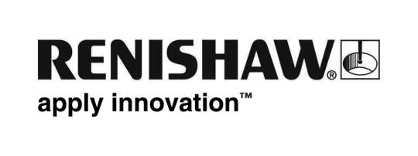
January 2016 Enquiries: Chris Pockett, Head of Communications (+44 1453 524133)

Renishaw renews sponsorship of Samson Lee

Global engineering company Renishaw has renewed its sponsorship of Scarlets Rugby star Samson Lee for the 2016/2017 season. The company is building relationships with organisations across South Wales as part of its long-term commitment to the development of activities at its site near Cardiff.

Lee is an internationally respected prop currently playing for the Llanelli-based Scarlets who are one of four professional Welsh regional rugby union teams. Lee made his international debut for Wales in 2013 and now regularly appears in the starting line-up.

Renishaw started sponsoring Lee last season and because of the player’s impressive performances for club and country, the decision to renew the sponsorship was an easy one. As part of its sponsorship, senior Renishaw managers attended the Scarlets’ 2016 end of season dinner where they met Lee and were able to brief him about the company’s activities in Wales.

“Samson Lee is a very talented player who is considered by many to be one of the best tight-head props in world rugby,” explained Chris Pockett, Head of Communications at Renishaw. ”He is an inspiration to the next generation through his hard work and ambition and this sponsorship ties in with Renishaw’s commitment to Wales and the development of young people in the region.”

“Since acquiring the 193 acre site at Miskin, Renishaw has been investing in the community and has experienced rapid growth from 25 employees in 2012 to 280 today,” continued Pockett. “The recent opening of the Renishaw Healthcare Centre of Excellence by the Welsh First Minister, Carwyn Jones, highlighted our ongoing commitment to growth in the region.”

As part of its wider community engagement, Renishaw also sponsors the Scarlets’ matchday TAG rugby where local schools and junior rugby clubs participate in pre-match games on artificial grass at the BT Supporters Village, then get to play on the hallowed turf of Parc y Scarlets at half-time.

In Wales, Renishaw also sponsors the Swansea City and South Korean football player Ki Sung-Yeung, whilst close to its headquarters site in Gloucestershire, the company has since 2012 been a sponsor of Ben Morgan, the Gloucester and England rugby international, who formerly played for the Scarlets.

Ends 357 words
Notes to editors
UK-based Renishaw is a world leading engineering technologies company, supplying products used for applications as diverse as jet engine and wind turbine manufacture, through to dentistry and brain surgery. It has over 4,000 employees located in the 35 countries where it has wholly owned subsidiary operations.

For the year ended June 2016 Renishaw recorded sales of £436.6 million of which 95% was due to exports. The company’s largest markets are China, the USA, Japan and Germany.

Throughout its history Renishaw has made a significant commitment to research and development, with historically between 14 and 18% of annual sales invested in R&D and engineering. The majority of this R&D and manufacturing of the company’s products is carried out in the UK.

The Company’s success has been recognised with numerous international awards, including eighteen Queen’s Awards recognising achievements in technology, export and innovation.

Renishaw is listed on the London Stock Exchange (LSE:RSW) where it is a constituent of the FTSE 250, with a current valuation of around £1.8 billion.

Further information at www.renishaw.com

