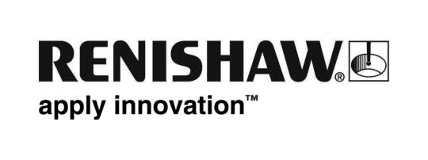
October 2017 Enquiries: Chris Pockett, Head of Communications (+44 1453 524133)

BLOODHOUND SSC gathers speed with Renishaw sponsorship

On October 26th, 2017, BLOODHOUND SSC, a supersonic car designed to break the world land speed record by reaching 1000 mph, will take to the runway for its first test in Newquay, UK. Global engineering technologies company, Renishaw has been named as a stripe sponsor for the car and an education sponsor for the BLOODHOUND project. The stripe sponsorship builds on Renishaw’s work to additively manufacture crucial components on the car and demonstrates its continued support for the project, which shares Renishaw’s focus on technical innovations and inspiring the next generation of engineers.

Renishaw has been involved with the project as a product sponsor since 2013, using its additive manufacturing expertise to create the titanium nose tip, which will be the first part of the car to cross the finish line, on its own metal additive manufacturing system. The company has also additively manufactured the car’s titanium steering wheel, designed specifically to match the contours of driver, Andy Green’s hands.

As a part of its new sponsorship package, Renishaw will attend the Newquay Public Day on Saturday 28th October and Education Day on Monday 30th October to support the BLOODHOUND Project’s goal of inspiring a new generation of engineers. Renishaw already offers an extensive education outreach programme across South Wales and Gloucestershire to encourage young people into engineering. In 2017, the company held a BLOODHOUND open day at its Gloucestershire headquarters, where 150 primary school children were able to see a full-scale model of the car to get them excited and engaged with the project.

“The car is an incredible feat of engineering and as the only UK manufacturer of metal additive manufacturing machines, it is fantastic to contribute to the iconic project both technically and financially,” explained Chris Pockett, Head of Communications at Renishaw. “Landmark projects have in the past had a demonstrable impact on engaging young people in science and engineering. This high-profile project is sure to inspire young people across the globe.”

“The Bloodhound SSC is a flagship UK engineering project,” said Tony Parraman, Head of Sponsor Liaison at The Bloodhound Project. “Working alongside some of the best in British engineering has enabled us to incorporate new and innovative technologies, like additive manufacturing, into the car itself.”

“Renishaw has excelled as a product sponsor so far, overcoming technical challenges in pressure and weight to produce components for the car,” continued Parraman. “Now, we are taking them on board as a stripe sponsor to strengthen this bond and add the company’s valuable support to our education outreach projects.”

For more information on Renishaw, visit www.renishaw.com.

Ends 406 words
Notes to editors
UK-based Renishaw is a world leading engineering technologies company, supplying products used for applications as diverse as jet engine and wind turbine manufacture, through to dentistry and brain surgery. It has over 4,000 employees located in the 35 countries where it has wholly owned subsidiary operations.

For the year ended June 2017 Renishaw recorded sales of £536.8 million of which 95% was due to exports. The company’s largest markets are China, the USA, Japan and Germany.

Throughout its history Renishaw has made a significant commitment to research and development, with historically between 14 and 18% of annual sales invested in R&D and engineering. The majority of this R&D and manufacturing of the company’s products is carried out in the UK.

The Company’s success has been recognised with numerous international awards, including eighteen Queen’s Awards recognising achievements in technology, export and innovation.

Further information at www.renishaw.com

