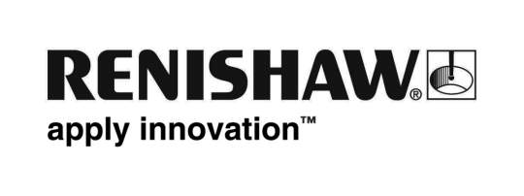
For immediate release

New incremental encoder interfaces with switchable resolutions are ideal for machines with two modes of operation

Renishaw announces a new line of TONiC™ TD incremental encoder interfaces that allow the user to switch between resolutions, simply by toggling the connection to a pin between 0 volts and open-circuit. This arrangement enables the encoder to provide two modes of operation – a high speed / coarser resolution mode for fast moves and a lower speed / fine resolution mode for precision operations. The switch-over can be carried out while the readhead is moving (as long as the controller allows it) and is completed in less than 1 ms. Alternatively, the interface can also be used for development purposes, enabling a designer to evaluate system performance at two different resolutions.

A variety of combinations are available. In all cases, the fine resolution output has twice the interpolation rate of the coarse resolution.

To maximise speed at all resolutions, TONiC interfaces have a range of clock frequencies optimised for a variety of industry-standard controllers, thus increasing potential work output of a machine. In this way, it is possible for certain controllers to realise the full speed capability of TONiC at fine resolutions.

TONiC incremental encoder interfaces with selectable resolution are designed for use with TONiC readheads which feature easy installation, a wide range of high-accuracy linear and rotary scales, dynamic signal processing for enhanced motion control performance and long-term reliability, plus the convenience of a super-compact body.

As with all Renishaw encoders, TONiC products are backed by a truly responsive global sales and support network. Furthermore it satisfies the highest environmental standards, with both WEEE and RoHS compliance.

-END-

