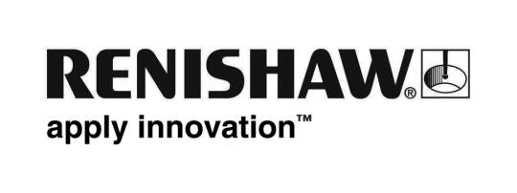
February 2017 Enquiries: Chris Pockett, Head of Communications (+44 1453 524133)

Renishaw hosts free Travel Show at Gloucestershire Headquarters

Global engineering and technology company, Renishaw, will be helping holiday-goers plan their perfect break at a free, family-friendly travel show this month. On Saturday 25th March, Wotton Travel Ltd (WTL), a wholly owned Renishaw company, will be hosting an exciting Travel Show offering visitors insight into top holiday destinations and personalised recommendations from leading tour operators. Taking place between 11am – 4pm in Renishaw’s £20m Innovation Centre near Wotton-under-Edge, attendees will also be able to take advantage of a range of exclusive travel discounts and win fantastic prizes.

The event will showcase a range of vacation options, from tailor-made holidays to city breaks and package holidays. Visitors will receive personalised advice and tips from leading tour operators.

There will also be plenty of opportunities to win prizes throughout the day. Each adult who attends the show will automatically be entered into a prize draw to win a luxury spa break with additional raffles taking place throughout the course of the event.

There will be 25 leading tour operators in the state-of-the-art Innovation Centre including; Mark Warner Holidays, Bakers Dolphin, Sandals Resorts, Saga Holidays, Exodus Travels, Inghams, Riviera Travel, North America Travel Service, Travel 2, Classic Collection Holidays, African Pride, Lusso Travel and Travelpack.

“Wotton Travel has over 200 years of travel industry experience,” explained Wendy Walker, Director of Wotton Travel. “This puts us in a fantastic position to give well-founded advice and recommendations. Our team carefully curates each holiday that it books, ensuring that our customers have a holiday to remember.

“Our experience sits perfectly alongside the opportunities to learn more from leading travel companies on the day. Visitors will be able to explore the many possible destinations available that fit their criteria before finally taking the plunge and booking that dream holiday.”

Wotton Travel is part of Advantage, the UK’s largest independent travel agent group. The company is also a part of the Advantage Focus Partnership, which supplies discounted flights. In 2016, Wendy Walker, Director of Wotton Travel was awarded the Outstanding Achievement Award at the inaugural Big Celebration Lunch, organised by Advantage.

To register for free tickets for the Travel Show visit https://www.eventbrite.co.uk/e/wotton-travel-show-2017-tickets-31637303025.

Ends 352 words
Notes to editors
UK-based Renishaw is a world leading engineering technologies company, supplying products used for applications as diverse as jet engine and wind turbine manufacture, through to dentistry and brain surgery. It has over 4,000 employees located in the 35 countries where it has wholly owned subsidiary operations.

For the year ended June 2016 Renishaw recorded sales of £436.6 million of which 95% was due to exports. The company’s largest markets are China, the USA, Japan and Germany.

Throughout its history Renishaw has made a significant commitment to research and development, with historically between 14 and 18% of annual sales invested in R&D and engineering. The majority of this R&D and manufacturing of the company’s products is carried out in the UK.

The Company’s success has been recognised with numerous international awards, including eighteen Queen’s Awards recognising achievements in technology, export and innovation.

Renishaw is listed on the London Stock Exchange (LSE:RSW) where it is a constituent of the FTSE 250, with a current valuation of around £2 billion.

Further information at www.renishaw.com

