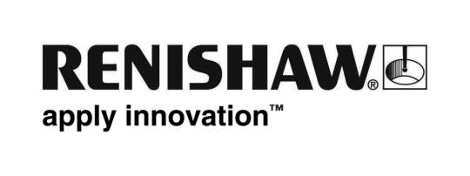
16 November 2015 Enquiries: Chris Pockett, Head of Communications (+44 1453 524133)

Renishaw presents new additive manufacturing products at formnext 2015
Renishaw, the global engineering technologies company is presenting new products at formnext 2015, which takes place in Frankfurt, from 17th-20th November 2015. The company will be exhibiting as Renishaw plc, with the main stand in Hall 3.1, stand E60 and as Renishaw LBC Engineering, on stand D78. The new products include two new metal additive manufacturing (AM) systems and a new build preparation software package.

Other highlights include Renishaw’s new global network of Solutions Centres and a live demonstration of the company’s capability in delivering comprehensive solutions for manufacturing and process control.

As official supplier to Land Rover Ben Ainslie Racing team and member of its Technical Innovation Group (TIG), Renishaw will use a metal 3D printed part for the T2 racing yacht to demonstrate how an additive metal part moves through an integrated, full production process chain.

With core skills in measurement, motion control, spectroscopy and precision machining, Renishaw has been applying its engineering excellence to help solve customers’ manufacturing challenges for over 40 years.

Early next year, the company is opening its doors to share its expertise via Additive Manufacturing Solutions Centres. Here manufacturers will benefit from dedicated incubator cells equipped with Renishaw AM systems. Customers can run an evaluation project to assess how AM might benefit their company with the support of Renishaw engineers. A key emphasis being on knowledge and skills transfer. The goal is to provide an insight into the technical and commercial benefits of AM and ultimately to provide the evidence to support investment in metal additive manufacturing technology.

RenAM 500M industrial metal additive manufacturing system (initially introduced as EVO Project)
Fully designed and engineered in-house to be used for serialised production, the RenAM 500M builds complex metal components directly from CAD using metal powder fusion technology. Highlights of the system include a Renishaw designed and engineered optical system with dynamic focussing; automated powder sieving and recirculation; 500 W ytterbium fibre laser and patented high capacity dual filter SafeChange™ system.

AM 400 metal additive manufacturing system
Formnext also sees the launch of the AM400 flexible metal additive manufacturing system. This new model is a development of the AM250 platform. It includes all the advantages of the latest machine updates with larger SafeChange™ filter, improved control software, revised gas flow and window protection system, and a new 400 W optical system that gives a reduced laser beam diameter of 70 micrometres.

QuantAM file preparation software
Renishaw has a long and successful track record of engineering software development, with a team of over 300 experienced software developers all working in-house. QuantAM is software used for build file preparation and is designed by Renishaw, specifically for the company’s additive manufacturing systems.

Renishaw Solutions Centres - a platform for innovative manufacturing
Renishaw Solutions Centres will provide a secure development environment in which customers can expand their knowledge and confidence using AM technology. They will be equipped with the latest AM systems and staffed by knowledgeable engineers to allow fast access to deploying the technology, all at fixed predictable costs.

For more information on Renishaw’s metal additive manufacturing products, please see:
www.renishaw.com/additive
Ends

