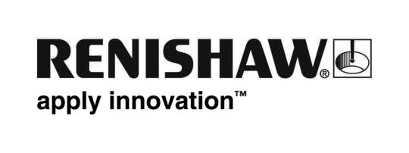
June 2017 Enquiries: Chris Pockett, Head of Communications (+44 1453 524133)

Girls get into STEM engineering at Renishaw

Global engineering technologies company, Renishaw hosted a series of Girls into Science, Technology, Engineering and Maths (STEM) engineering days in June, 2017 at its Miskin site in South Wales. These three activity days for local school girls, on June 19th, 22nd and 29th, aimed to inspire the female engineers of the future with hands-on activities and provided an introduction to career opportunities in the sector.

Renishaw collaborated with the Engineering Education Scheme Wales (EESW) to advertise these events to schools in the local area. One of EESW’s staff, along with Sarah Lewis, Fabrication Development Centre (FDC) Tutor at Miskin and two female engineers from Renishaw’s Gloucestershire base ran sessions on engineering and software skills.

Groups of year 8 and 9 female students were given a guided tour of the Miskin manufacturing site and learned about engineering careers at Renishaw. The girls also participated in hands-on activities including C++ coding for ‘RenBed’ buggies that are programmed with line code to guide them around a track. The aim of this event was to help girls understand that software coding is important for everyday engineering and give them insight into a subject that may be a potential career opportunity for them in the future.

“We hope that education days like these will help close the gender gap in the engineering sector and encourage more girls to study engineering in secondary school and higher education,” explained Rebecca Bound, Education Outreach Officer at Renishaw. “The success of last year’s event lead many of the schools to return for other workshops, compelling us to continue these activity days. Girls must understand that engineering can be a good career prospect for them.”

“With very few female engineers in the sector, as well as a growing skills gap, employers need to do more to promote STEM subjects to girls. Renishaw’s education outreach programme hosts many events that encourage future engineers to join our apprenticeships and graduate schemes,” explained Chris Pockett, Head of Communications at Renishaw. “This event gave female students insight into the potential opportunities in the sector and the different paths that they can take into a career in engineering.”

EESW is a charity that collaborates with businesses to run educational schemes across Wales, motivating young people to further their education in STEM subjects. Participating students can learn essential skills to improve their employability, while gaining practical experience in industry by visiting companies such as Renishaw.

The Girls into STEM engineering event also coincided with National Women in Engineering Day, on June 23rd. This day celebrates the achievements of female engineers, who act as role models for girls that are interested in science but unsure of how to start a career in the sector.

For more information about events run by Renishaw’s education outreach programme, visit http://www.renishaw.com/en/education-outreach--34713

Ends 461 words
Notes to editors
UK-based Renishaw is a world leading engineering technologies company, supplying products used for applications as diverse as jet engine and wind turbine manufacture, through to dentistry and brain surgery. It has over 4,000 employees located in the 35 countries where it has wholly owned subsidiary operations.

For the year ended June 2017 Renishaw recorded sales of £536.8 million of which 95% was due to exports. The company’s largest markets are China, the USA, Japan and Germany.

Throughout its history, Renishaw has made a significant commitment to research and development, with historically between 14 and 18% of annual sales invested in R&D and engineering. The majority of this R&D and manufacturing of the company’s products is carried out in the UK.

The Company’s success has been recognised with numerous international awards, including eighteen Queen’s Awards recognising achievements in technology, export and innovation.

Renishaw is listed on the London Stock Exchange (LSE:RSW) where it is a constituent of the FTSE 250, with a current valuation of over £3 billion.

Further information at www.renishaw.com

