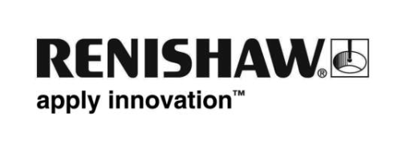
April 2012 – for immediate release
Further information: Chris Pockett, +44 1453 524133 Bo Eneholm (Nordic), +46 8584 90 880

New dental business manager appointed at Renishaw AB

Renishaw AB, the Nordic subsidiary of Renishaw plc, the global specialists in precision metrology and healthcare technologies, has appointed a new Business Manager for its range of dental CAD/CAM products. Håkan Roos is a certified dental technician and has over 25 years of experience working within the dental industry for a variety of respected companies.

Based in Järfälla, Sweden, Renishaw AB’s dental operation was strengthened in February 2012 when Håkan joined the company, contributing to its existing high level of experience and solution-oriented customer service. His most recent position was with Biomet 3i, where as Manager, Digital Dentistry & Laboratory Sales, he was part of the leadership team. He has also occupied managerial positions for the Implant Departments at Tandtekniska Laboratoriet and for Sydlab AB, and worked within the Nordic sales and marketing operation of Ivoclar-Vivadent.

Speaking about the new appointment, Renishaw AB's general manager, Bo Eneholm, says, “It is a pleasure to welcome Håkan Roos to Renishaw AB as Dental Business Manager. His long experience in the dental business, combined with his skills and customer knowledge, will give us a good opportunity to continue our growth for this product line. We all look forward to working closely with him, and I wish Håkan all the success at Renishaw AB.”

The Renishaw® incise™ dental CAD/CAM system combines precision engineering with state-of-the-art materials to produce highly accurate, consistent and durable dental restorations.

For more information, please go to www.renishaw.com.

- ENDS -

