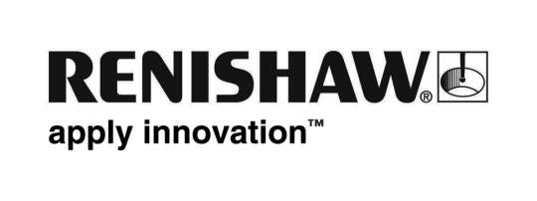
August 2017 Enquiries: Chris Pockett, Head of Communications (+44 1453 524133)

Local Brownie group earns badge of engineering honour at Renishaw

Global engineering technologies company, Renishaw, recently hosted a local Brownie group at its Miskin site in South Wales to help them earn a new badge in engineering.

The Brownie group leader collaborated with Renishaw to give the members a project to design and engineer their own name badges for their uniforms. The girls took part in three sessions to earn their badge.

In the first session, the Brownies designed their name badges by hand, to include their name and the brownie logo. The following week Renishaw gave the girls a tour of the factory and they transferred their image from paper to digital format using computer aided design (CAD). The girls saw the first of their designs realised on the 3D printer. In the final session, Sarah Lewis, fabrication development centre (FDC) tutor at Renishaw’s Miskin site, visited the brownie group to deliver the finished pin badges for their uniforms.

“It is a common misconception that engineers are predominantly boys. By getting girls interested in engineering during extra-curricular activities we hope to get them thinking about the opportunities available in engineering careers,” explained Simon Biggs, Education Liaison Officer at Renishaw. “Other groups are approaching us asking how they can get a new badge in engineering. The prospect of competition has encouraged more groups to ask for sessions at Renishaw, supporting our aim to get more children excited about engineering.”

“Our education outreach programme has worked with schools for many years to try and get children interested in science and dispel any stereotypes about engineering,” explained Chris Pockett, Head of Communications at Renishaw. “By organising extra-curricular engineering activities, Renishaw can show children how interesting the sector can be.

“Children always have something to take home after taking part in a Renishaw educational day. The brownie badge reminds them of their achievement and they can use it to show their peers the exciting possibilities of engineering.”

"The Brownies were extremely grateful for the opportunity to experience something new and exciting,” Steph Horsley 1st Llanharan Brownie Leader. “It is a fantastic resource and to be able to try things that we cannot do in our own units is essential to developing the girls and hopefully inspiring them for the future. We thoroughly enjoyed it.”

Renishaw’s education outreach programme aims to promote engineering career opportunities to young children. Over the last year, it has held work experience days, education days with the Bloodhound Supersonic Car and other activities to inspire the engineers of the future.

To find out more about the educational opportunities at Renishaw for local schools visit http://www.renishaw.com/en/education-outreach--34713.

Ends 427 words
Notes to editors
UK-based Renishaw is a world leading engineering technologies company, supplying products used for applications as diverse as jet engine and wind turbine manufacture, through to dentistry and brain surgery. It has over 4,000 employees located in the 35 countries where it has wholly owned subsidiary operations.

For the year ended June 2016 Renishaw recorded sales of £436.6 million of which 95% was due to exports. The company’s largest markets are China, the USA, Japan and Germany.

Throughout its history Renishaw has made a significant commitment to research and development, with historically between 14 and 18% of annual sales invested in R&D and engineering. The majority of this R&D and manufacturing of the company’s products is carried out in the UK.

The Company’s success has been recognised with numerous international awards, including eighteen Queen’s Awards recognising achievements in technology, export and innovation.

Renishaw is listed on the London Stock Exchange (LSE:RSW) where it is a constituent of the FTSE 250, with a current valuation of around £1.8 billion.

Further information at www.renishaw.com

