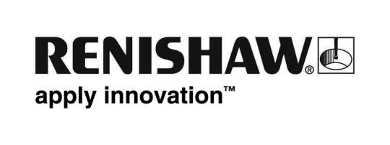
May 2019 Enquiries: Chris Pockett, Head of Communications (+44 1453 524133)

Best employer award for Renishaw associate company
RLS d.o.o, a Renishaw associate company, has again been awarded a Best Employer in Slovenia Award. At the Golden Thread Awards 2018, held in March 2019 in Ljubljana, RLS picked up the accolade for best medium-sized enterprise. Renishaw d.o.o was also shortlisted in the Small Business Category after entering the competition for the first time.
The competition identifies and promotes the best employers and promotes best practices in employee relations to influence the development of jobs and contribute to the competitiveness of the Slovenian economy. The scheme is organised by Slovene national media house Dnevnik in collaboration with HR and Economics professionals from the University of Ljubljana. The competition has been running since 2007 and is supported by prominent representatives from the business community and academia.
Renishaw d.o.o was also shortlisted in the Small Business Category in its inaugural entry. The company was set up in 2015 as a research and development organisation, located within the Faculty of Electrical Engineering at the University of Ljubljana. It was formally opened in June by Sir David McMurtry, co-founder of Renishaw. Renishaw d.o.o designs, develops and supplies integrated circuits and sensor technologies for the Renishaw Group and RLS.
“RLS is a dynamic, growing company that looks after its employees,” explained Chris Pockett, Head of Communications at Renishaw. “The company promotes diversity, has a strong company culture and provides an innovative environment for employees to grow and develop. Renishaw congratulates RLS on once again being named as a leading Slovenian business.”
RLS and its employees have already been recognised in 2019. Dora Domajnko, a Development Engineer at RLS, was named Slovenia’s first ever Female Engineer of the Year in January 2019. Domajnko has had an impressive career to date, working at RLS to develop mathematical algorithms for rotary and linear magnetic encoders while studying for her PhD.
RLS d.o.o is a world-leader in the development of high-performance magnetic encoder feedback solutions. It works with associate company Renishaw to offer worldwide sales and technical support. Renishaw took a 50 per cent shareholding in RLS in 2000, giving the Slovenian company access to its global distribution strength and applications experience as a position encoder supplier.
For more information, visit www.renishaw.com.
Ends 357 words
Notes to editors
UK-based Renishaw is a world leading engineering technologies company, supplying products used for applications as diverse as jet engine and wind turbine manufacture, through to dentistry and brain surgery. It has over 4,500 employees located in the 36 countries where it has wholly owned subsidiary operations.

For the year ended June 2018 Renishaw recorded sales of £611.5 million of which 95% was due to exports. The company’s largest markets are China, the USA, Germany and Japan.

Throughout its history Renishaw has made a significant commitment to research and development, with historically between 13 and 18% of annual sales invested in R&D and engineering. The majority of this R&D and manufacturing of the company’s products is carried out in the UK.

The Company’s success has been recognised with numerous international awards, including eighteen Queen’s Awards recognising achievements in technology, export and innovation.

Further information at http://www.renishaw.com/

