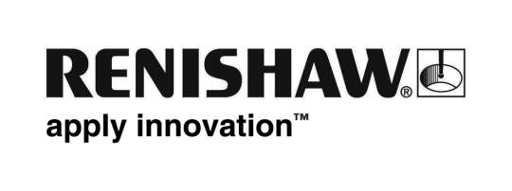
July 2019 Enquiries: Chris Pockett, Head of Communications (+44 1453 524133)

Renishaw apprentice gains international experience
Ryan Harris, an apprentice at global engineering technologies company, Renishaw, participated in a two-week Erasmus programme in Germany, funded by the European Union (EU). The programme gives Welsh college students first-hand experience of engineering in another country and broadens their knowledge of the industry by showing them different approaches.

As part of the Erasmus programme, four students from Coleg Y Cymoedd were selected for work-experience at Stadler Anglenbau GmbH, including an all-expenses paid trip to the company’s facility in Altshausen, Baden-Württemberg. Stadler Anglenbau designs and manufactures waste sorting plants and components for waste management and recycling.

In the first week of the programme, students were placed with German apprentices to learn about their roles and how they differed from the UK. In the second week, they were then placed in different areas of production to learn how end-products are created from raw materials. The students were also shown technologies, including ballistic separators, to learn about how they operate in the waste management industry.

“I’ve had an interest in engineering since I was very young and that is why I’m choosing it is as a career,” explained Ryan Harris, the apprentice at Renishaw’s Miskin site in South Wales who took part in the scheme. “The experience gave me a different perspective on the engineering work I have done at Renishaw, for example a different approach to engineering standards and tolerances. I was able to apply the emphasis on accuracy and precision I learnt at Renishaw in a completely new environment.”

“The scheme enabled me to learn from and work with peers who have come through a different education system,” added Harris. “I’m really glad that I got to take part in the programme because it really opened my eyes to a new industry, a new country and a new approach. This additional perspective will help me to approach the engineering challenges I am working on as part of my apprenticeship at Renishaw.”

“It’s fantastic to hear such positive feedback from students who took part in the Erasmus programme,” explained Chris Pockett, Head of Communications at Renishaw. “Renishaw runs apprenticeship schemes every year that offer in-house training, a great work environment and a competitive salary.

“We’re proud to offer our apprentices the chance to develop their skills and become the leaders of tomorrow,” added Pockett. “Schemes like the Erasmus programme offer a new experience for our apprentices to help them to broaden their knowledge of engineering and open their minds to how they would like to develop their own careers.”

Renishaw will welcome its largest ever cohort of engineering apprentices in September 2019. To find out more about apprenticeship opportunities at Renishaw, visit www.renishaw.com/apprenticeships.

Ends 442 words
Notes to editors
UK-based Renishaw is a world leading engineering technologies company, supplying products used for applications as diverse as jet engine and wind turbine manufacture, through to dentistry and brain surgery. It has 5,000 employees located in the 36 countries where it has wholly owned subsidiary operations.

For the year ended June 2019 Renishaw recorded sales of £574 million of which 94% was due to exports. The company’s largest markets are the USA, China, Japan and Germany.

Throughout its history Renishaw has made a significant commitment to research and development, with historically between 13 and 18% of annual sales invested in R&D and engineering. The majority of this R&D and manufacturing of the company’s products is carried out in the UK.

The Company’s success has been recognised with numerous international awards, including eighteen Queen’s Awards recognising achievements in technology, export and innovation.

Further information at www.renishaw.com

