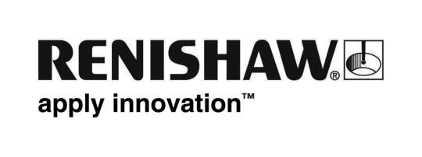
July 2019 Enquiries: Chris Pockett, Head of Communications (+44 1453 524133)

Super Science competition winners improve STEM education
Global engineering company, Renishaw, has awarded £10,000 of prize money to six local schools who won its Super Science competition, held in collaboration with the Bristol Post and BristolLive. The winners are using their prize money to purchase resources and fund activities to support the science, technology, engineering and maths (STEM) curriculum to get pupils excited about these subject areas.

This year’s Super Science competition saw 3,348 prize draw entries submitted for 130 schools across the Bristol region, before the winners were selected at random. Unlike previous years, the prize money was split across six winning schools, rather than going to one school. This meant that more children were able to benefit from the prize money.
There were three winning primary schools: Stoke Bishop Primary, which was awarded the top prize of £3,000; Wheatfield Primary School, which took home £1,500; and St. Barnabas CE VC Primary School which received £500. The top prize in the secondary school section went to Mangotsfield School, with Bradley Stoke Community School placed second and The Castle School winning third prize. The winning schools attended a prize giving event at Renishaw’s headquarters near Wotton-under-Edge, Gloucestershire, where they learnt about the company’s world-leading technologies and its large investment in STEM education programmes.
“We are going to invest some of the money into high quality science equipment so that pupils can participate in the CREST Award,” explained David Smith, Principal of Mangotsfield School. “They can then put the award onto their CV for their university applications. This will enable pupils to engage in additional STEM activities and better prepare themselves for studying STEM at a higher level.”
“Our staff and parents are keen to build on the children’s STEM learning and we are grateful to Renishaw for the opportunity to do something different,” added David Forrester, Headteacher at Stoke Bishop Primary School. “Thanks to the prize money, we are going to dedicate a room in the school as our own Innovation Hub. In the facility, we will set the children challenges that require critical thinking and problem solving.
“Initially we will be working with materials such as Lego and K’NEX, but we will soon allocate resources to ensure that children have the opportunity to model and even build their solutions,” added Forrester. “The use of IT programs to support this process is also something we want to explore.”
The Super Science competition is part of Renishaw’s comprehensive education outreach programme. The scheme aims to engage students by running a wide range of engineering activities to promote STEM learning. For more information on how to get involved, visit https://www.renishaw.com/educationoutreach.
Ends 431 words
Notes to editors
UK-based Renishaw is a world leading engineering technologies company, supplying products used for applications as diverse as jet engine and wind turbine manufacture, through to dentistry and brain surgery. It has over 4,500 employees located in the 36 countries where it has wholly owned subsidiary operations.

For the year ended June 2018 Renishaw recorded sales of £611.5 million of which 95% was due to exports. The company’s largest markets are China, the USA, Germany and Japan.

Throughout its history Renishaw has made a significant commitment to research and development, with historically between 13 and 18% of annual sales invested in R&D and engineering. The majority of this R&D and manufacturing of the company’s products is carried out in the UK.

The Company’s success has been recognised with numerous international awards, including eighteen Queen’s Awards recognising achievements in technology, export and innovation.

Further information at http://www.renishaw.com/

