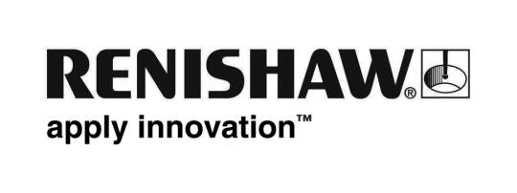
January 2019 Enquiries: Chris Pockett, Head of Communications (+44 1453 524133)

Renishaw expands European reach of AM Solutions Centres
To accelerate the adoption of laser powder bed fusion for series production applications, engineering company Renishaw has expanded its global network of additive manufacturing (AM) Solutions Centres. New facilities in Barcelona, Spain and Torino, Italy are now operational to allow local companies to access Renishaw’s equipment and expertise at a fixed and predictable cost.

Launched in 2016, Renishaw’s Solutions Centres enable businesses a secure development environment to build their knowledge and confidence using AM technology. The facilities are equipped with the latest AM systems, including Renishaw’s multi-laser machines, alongside all the metrology, finishing and machining equipment required to make a functional part.

Users of Renishaw’s Solutions Centres run projects to build their knowledge of the AM process, understand the product performance impact and assess the capability and costs of the technology. The centres are staffed by local AM specialists, who work closely with customers on the engineering projects. Renishaw offers support throughout the investigation and business case development process, so companies can optimise their designs and gain the required evidence to make investment decisions.

“The Solutions Centres have proved to be a successful way for manufacturers to accelerate learning about this new technology,” explained Marc Saunders, Director of Global Solutions Centres at Renishaw. “Early users of the Solutions Centres, who have benefitted from accessing our facilities, are now deploying Renishaw’s multi-laser, productive additive manufacturing systems in their own facilities.

“We have opened the new facilities to be closer to our Spanish and Italian customers,” added Saunders. “By expanding the network, we are able to help more customers move forward on the journey to industrial AM.”

Renishaw has invested significantly in its subsidiary network, comprising of over 70 offices in 36 countries. It has recently expanded to new, larger locations in Barcelona, Spain and Torino, Italy, which has enabled the establishment of new Solutions Centres.

Renishaw now has AM Solutions Centres operational in India, Canada, America, China, Germany, the United Kingdom, Spain and Italy. For more information and to find your nearest Solutions Centres, visit www.renishaw.com/solutionscentres.

Ends 343 words
Notes to editors
UK-based Renishaw is a world leading engineering technologies company, supplying products used for applications as diverse as jet engine and wind turbine manufacture, through to dentistry and brain surgery. It has over 4,500 employees located in the 36 countries where it has wholly owned subsidiary operations.

For the year ended June 2018 Renishaw recorded sales of £611.5 million of which 95% was due to exports. The company’s largest markets are China, the USA, Germany and Japan.

Throughout its history Renishaw has made a significant commitment to research and development, with historically between 13 and 18% of annual sales invested in R&D and engineering. The majority of this R&D and manufacturing of the company’s products is carried out in the UK.

The Company’s success has been recognised with numerous international awards, including eighteen Queen’s Awards recognising achievements in technology, export and innovation.

Further information at www.renishaw.com

