



Date: Press release – 26th May 2016

**Engineered. Bespoke. – The R160**

**A collaboration of cutting edge technology and companies, anthropometry, and years of experience has led to the unveiling of the new Robot Bike Co. R160 mountain bike frame – designed and manufactured in the UK with partner companies Altair, HiETA Technologies and Renishaw using metal additive manufacturing (3D printing).**

A great design freedom has been achieved through the development of a unique construction using titanium lugs, proprietary carbon fibre components and tubing and a double lap joint bonding concept. Through the experience of the partner companies each frame can be tailored to a customer’s individual measurements or specifications, with the added benefit that the frame can be constantly improved as new technologies emerge, as the production process is not constrained by a mould.

The new frame concept was developed by the Robot Bike Co. which was founded by Ben Farmer, Ed Haythornthwaite, Andy Hawkins and Ben Robarts-Arnold in 2013. Robot Bike have a clear mission… to make the best mountain bike frames possible.

Each of the partners are leaders in its own technology fields and the frame design and engineering are therefore grounded in years of experience in demanding sectors such as aerospace, automotive and F1. The suspension design has been developed and tailored for Robot Bike Co. by Dave Weagle, one of the world’s foremost suspension designers, who has a proven track record developing original and class leading suspension designs for mountain bikes.

HiETA is a specialist additive manufacturing development and project engineering company based in the Bristol and Bath Science Park. With 25 specialist engineers it covers product design, manufacturing readiness and project management services from conceptual design and process development through to early stage manufacturing support, providing its clients and users with the process and facilitating the delivery of innovative products from concept through to end product and commercialisation.

Mike Adams CEO of HiETA said “One of the great aspirations of additive manufacturing has always been “mass customisation”. Leading this project has allowed us to see integration of all the elements – a great new frame design, the use of state of the art software tools for optimisation and automation, the flexibility of the manufacturing process itself and effective collaboration between our partners is a great advert for the technologies and the South West of England showcasing that the aspiration is becoming a reality.”

Simulation specialists, Altair, was made responsible for the optimisation of the bike’s additively manufactured connecters. Using solidThinking Inspire, Altair was able to maximize the benefit of additive manufacturing by identifying where material in the connectors could be removed to save weight and reduce part count without compromising performance. These engineering techniques are commonly used throughout the automotive and aerospace industries to maximize product performance but are equally valuable to bike manufacturers.

“This has been a very interesting and exciting project to be involved with,” said Paul Kirkham, Team Leader at Altair’s Bristol office. “Additive manufacturing is the perfect partner for design optimisation techniques as it allows us to produce components and systems that are far closer to the ideal balance of weight and performance. Robot Bike Co. now have a design that will offer its customer a bike that is truly innovative and unique.”

Renishaw is a world leader in dimensional metrology, spectroscopy and healthcare, applying its expertise to improve operational efficiencies in a vast range of industries and applications, from aerospace and renewable energy to dentistry and brain surgery. It is also the UK’s only manufacturer of metal additive manufacturing systems.

Marc Saunders, Director – Global Solutions Centres for Renishaw, says, “We have been delighted to lend our expertise in additive manufacturing, machining and metrology to deliver a high quality bike frame from an initial design concept. This typifies the approach that we are taking with our Solutions Centres, where we are working closely with our customers to create designs that maximise the production and lifetime benefits that can be gained from using an additive manufacturing process.”

It doesn’t matter how good a frame is if it doesn’t fit the rider, and this is where Robot Bike Co. sees the weakness in the current market offerings. Says RBC’s Ed Haythornthwaite, “If you are trying to produce the very best frame it makes no sense to then only offer it in a small number of sizes when the people you are selling it to come in all shapes and sizes. Think of Robot Bike Co. as the Savile Row of the bike world.”

The retail price will be around £4,395 with a lead time of 4 weeks, and the frames will be available to order from June 2016.

***Editors Note:***

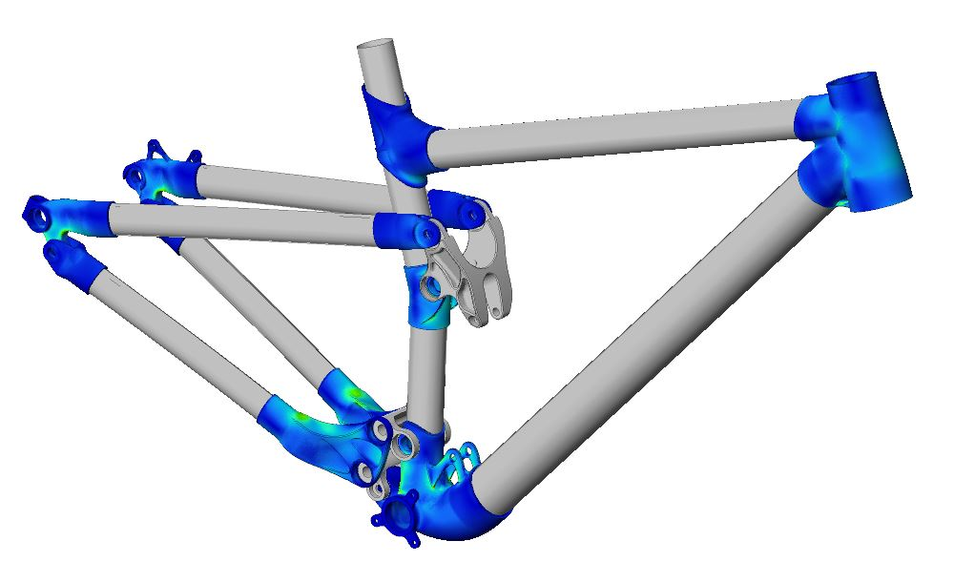

***Altair Performed Design Optimisation with solidThinking Inspire & Detailed Design Verification with OptiStruct***

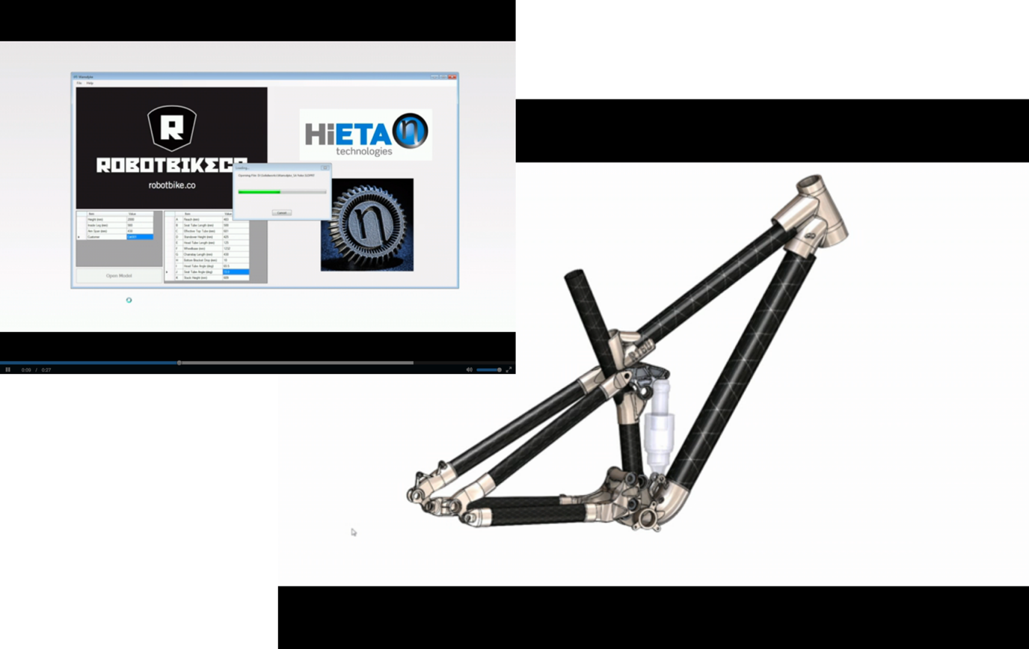

***HiETA’s Customisation and Parametric Modelling Tool***

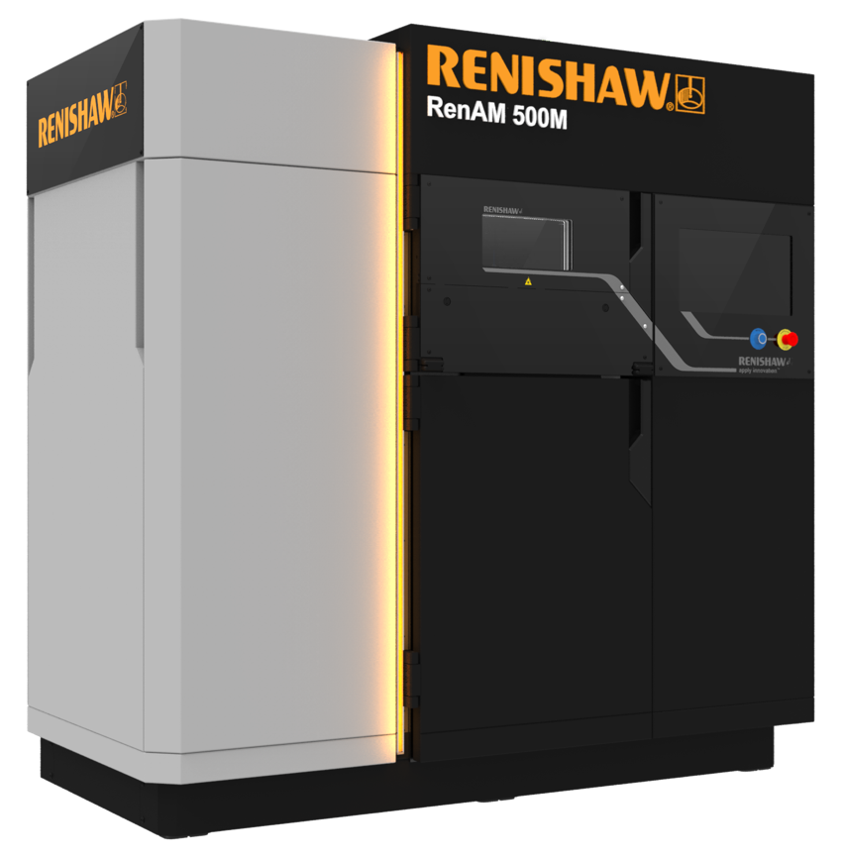

***Example of a Renishaw additive manufacturing machine***

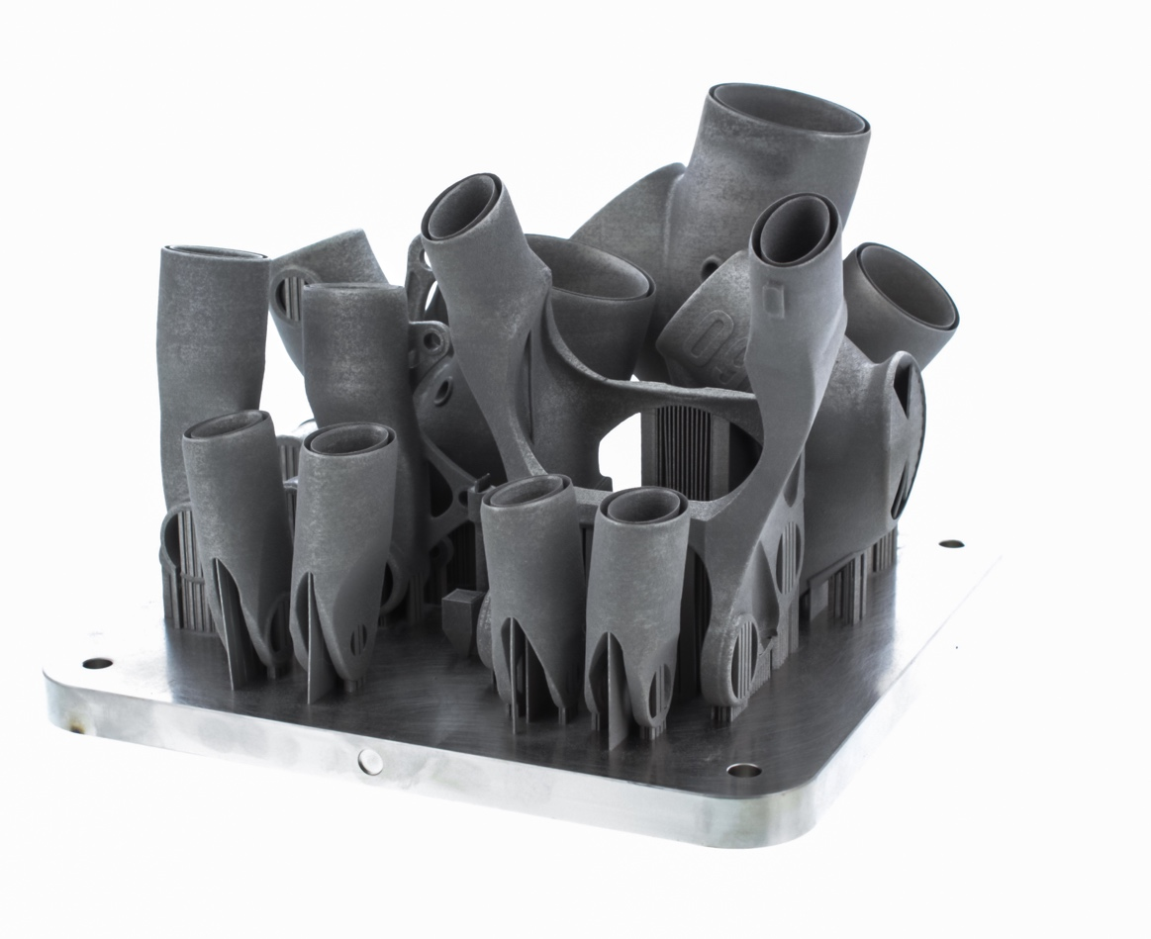

***The R160 Build Plate with printed titanium lugs***

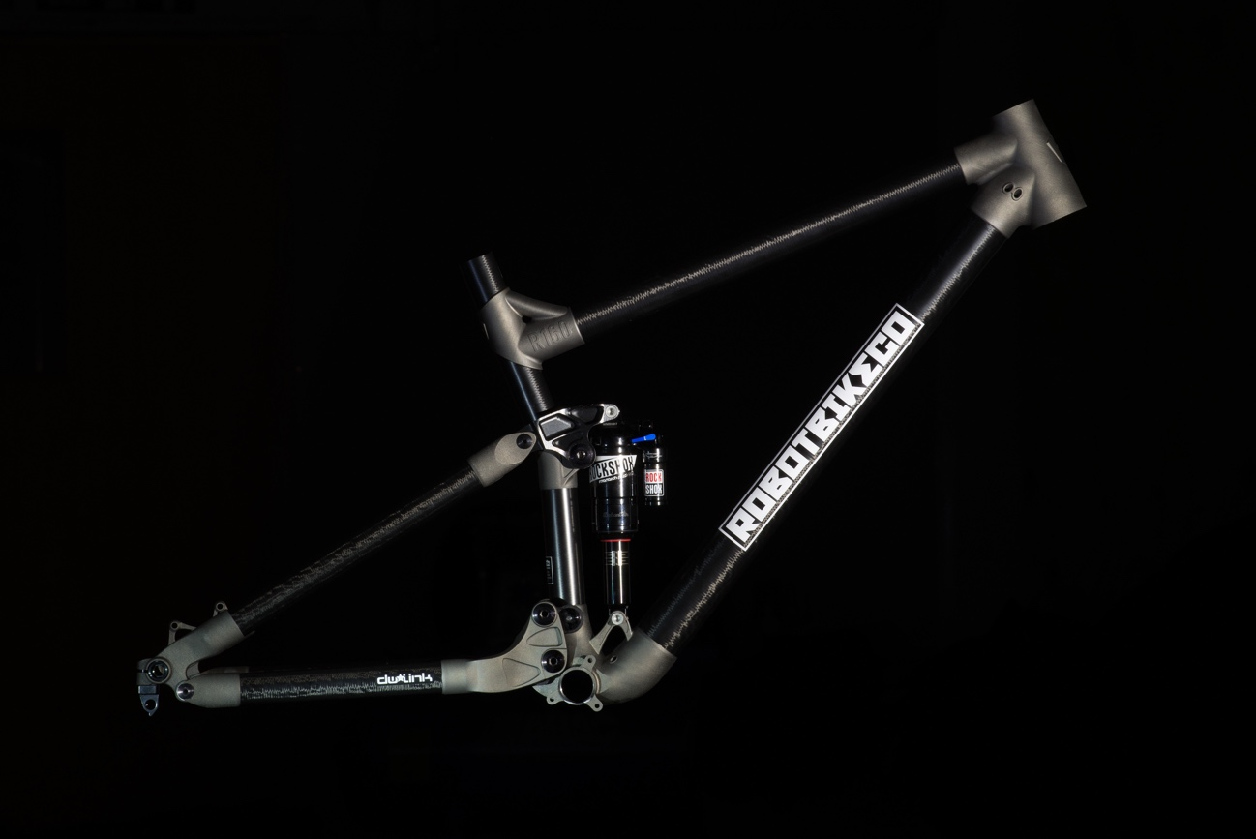

***Robot Bike Co. The 160 Frame***

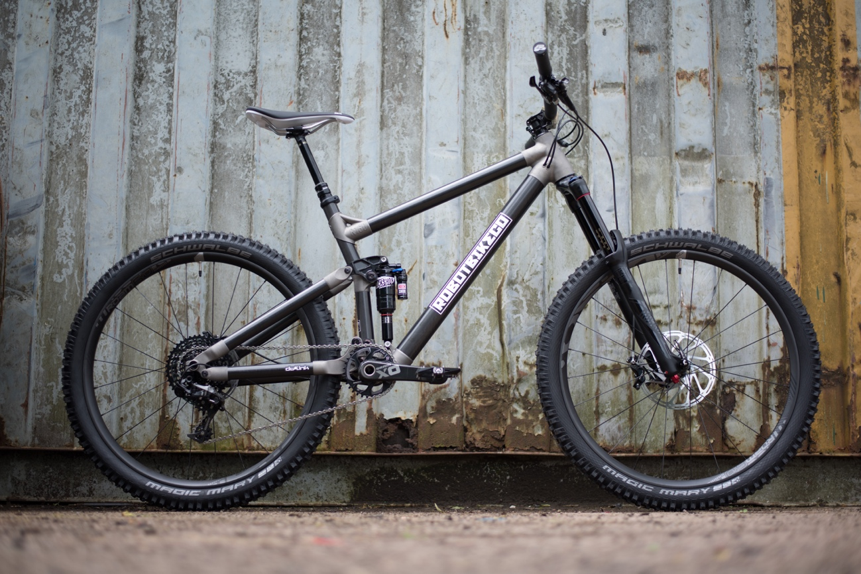

***Robot Bike Co. The 160 Bike***

**About Robot Bike Co.** Robot Bike Co. was created in 2013, yet the dream of making the best possible mountain bikes can be traced back over a decade further to when three of the four founders spent too many of their university days sketching out countless bicycle ideas. Fast forward and a wealth of experience had been amassed in various industries, including cycle, F1 and aerospace, and from that knowledge came the realization that advances in technology meant that dreams could finally become reality. Robot Bike Co. have worked closely with Dave Weagle and now design and hand make custom mountain bike frames in the heart of the Wye Valley. **www.robotbike.co**

**About Altair** Altair is focused on the development and broad application of simulation technology to synthesize and optimize designs, processes and decisions for improved business performance. Privately held with more than 2,600 employees, Altair is headquartered in Troy, Michigan, USA and operates more than 45 offices throughout 24 countries. Today, Altair serves more than 5,000 corporate clients across broad industry segments.

**www.altair.com**

**About HiETA Technologies**

HiETA Technologies, based from its Technology Centre at the Bristol & Bath Science Park. A specialist additive manufacturing development and project engineering company covering product design, manufacturing readiness and project management services from early stage design and process development through to early stage manufacturing support providing its clients and users with the process and facilitating the delivery of innovative products from concept through to end product and commercialisation. Privately held with 25 specialist engineers, HiETA works closely with Innovate UK; the Centre for Defence Enterprise; and on numerous commercial projects in F1, automotive, aerospace, defence and clean energy.

**www.hieta.biz**

**About Renishaw**

Renishaw is one of the world's leading engineering and scientific technology companies, with expertise in precision measurement and healthcare. The company supplies products and services used in applications as diverse as jet engine and wind turbine manufacture, through to 3D printing, dentistry and brain surgery.

The Renishaw Group currently has more than 70 offices in 35 countries**,** with over 4,000 employees, of which 2,700 people are employed within the UK. For the year ended June 2015 Renishaw achieved sales of £494.7 million of which 95% was due to exports. The company's largest markets are China, USA, South Korea, Germany and Japan.

**www.renishaw.com**