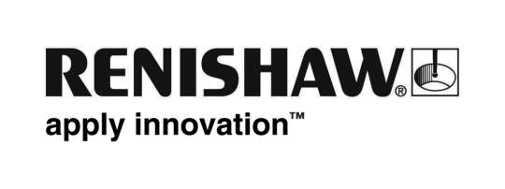
January 2020 Enquiries: Chris Pockett, Head of Communications (+44 1453 524133)

Renishaw celebrates Bloodhound’s South Africa test
A titanium nose tip and steering wheel additively manufactured by global engineering technologies company Renishaw has been used to optimise the supersonic car that aims to break land speed record in South Africa. Both parts were used in the Bloodhound SSC (now Bloodhound LSR) car that reached its benchmark target of 500 mph in the South African desert in November 2019.

BLOODHOUND is the project behind the technologically advanced supersonic car that was taken out to South Africa, where driver Andy Green managed to log a speed of 628 mph on the 12.4-mile Hakskeen Pan track. Renishaw began working with BLOODHOUND back in 2013 when it became a sponsor, and since then Renishaw has provided its additive manufacturing (AM) expertise to design and manufacture parts for the supersonic car.

Renishaw’s technology was used to build the car’s steering wheel layer-by-layer from titanium powder. The bespoke design enabled the wheel to specifically fit the hands of Andy Green, to assist him when controlling the car at extreme speeds. Renishaw also used its AM expertise to design and produce the car’s nose tip. Again, this was manufactured from titanium powder to provide a strong, lightweight component, capable of dealing with the extreme loadings that occur when the car is at high speeds.

“Reaching 628 mph in South Africa was an incredible achievement for BLOODHOUND and it was exciting to see Renishaw’s technology being a part of it,” explained Chris Pockett, Head of Communications at Renishaw. “Additive manufacturing gave us the freedom to design the nose cone and steering wheel specifically to undergo the extreme forces involved in the land speed attempt, which would have been difficult with traditional manufacturing methods.”

With Bloodhound LSR having broken the 500 mph barrier in the South Africa test, it is now setting its sights on breaking the land speed record in 2020/21. BLOODHOUND previously reached speeds of 200 mph while trialling the supersonic car at Cornwall Airport, Newquay in 2017.

To find out more about Renishaw’s additive manufacturing products and services, visit http://www.renishaw.com/additive-manufacturing

Ends 337 words
Notes to editors
UK-based Renishaw is a world leading engineering technologies company, supplying products used for applications as diverse as jet engine and wind turbine manufacture, through to dentistry and brain surgery. It has over 4,500 employees located in the 36 countries where it has wholly owned subsidiary operations.

For the year ended June 2018 Renishaw recorded sales of £611.5 million of which 95% was due to exports. The company’s largest markets are China, the USA, Germany and Japan.

Throughout its history Renishaw has made a significant commitment to research and development, with historically between 13 and 18% of annual sales invested in R&D and engineering. The majority of this R&D and manufacturing of the company’s products is carried out in the UK.

The Company’s success has been recognised with numerous international awards, including eighteen Queen’s Awards recognising achievements in technology, export and innovation.

Further information at http://www.renishaw.com/

