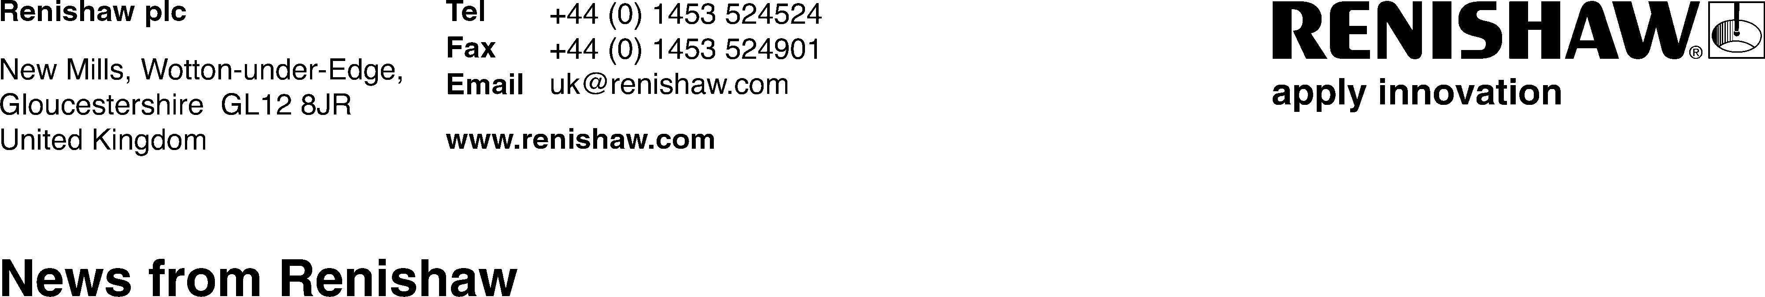

*September 2025 - For immediate release*

Renishaw appoints new Group Human Resources Director

Global engineering technologies company, [Renishaw](https://www.renishaw.com/en/renishaw-enhancing-efficiency-in-manufacturing-and-healthcare--1030?utm_source=google&utm_medium=article&utm_campaign=REC1039&utm_id=new+hr+director&utm_term=new+hr+director&utm_content=Earned), is pleased to announce the appointment of Clare Nicholls as its new Group Human Resources Director, effective 1 September 2025. Clare joins the Company’s Executive Committee, bringing over 25 years of global HR leadership across the manufacturing and engineering sectors.

Clare joins from TT Electronics, where she most recently held the position of EVP Human Resources. Before joining TT, Clare worked at Boeing across its non-US business, and for Tata Steel and its predecessors across Europe. Her expertise in business transformation, cultural engagement, and talent development aligns closely with Renishaw’s strategic priorities. Driven by a lifelong passion for science and engineering, Clare holds an MA in Natural Sciences from the University of Cambridge.

In her new role, Clare will lead the implementation of Renishaw’s global people strategy, with a focus on people development, strengthening organisational culture, and building capability across the business. She will also oversee HR and Health & Safety services worldwide, including early careers and STEM outreach.

“Clare’s proven experience in managing change within relevant industry sectors and diverse geographies will be invaluable as Renishaw enters its next phase of growth and innovation,” said Will Lee, Renishaw’s Chief Executive Officer. “Her strategic mindset and people-first approach are a perfect fit for our evolving business.”

Commenting on her appointment, Clare said: “I’m delighted to be joining Renishaw and look forward to working with employees across the business. I’m excited to help shape the company’s future by building on its strong commitment to people and innovation.”

For further information about Renishaw’s leadership team, visit [www.renishaw.com/en/our-people--21969](https://www.renishaw.com/en/our-people--21969)

**-ENDS-**

**About Renishaw:**

Renishaw is a world leading supplier of measuring systems and manufacturing systems. Its products give high accuracy and precision, gathering data to provide customers and end users with traceability and confidence in what they’re making. This technology also helps its customers to innovate their products and processes.

It is a global business with over 5,000 employees located in the 36 countries where it has wholly owned subsidiary operations. The majority of R&D work takes place in the UK, with the largest manufacturing sites located in the UK, Ireland and India.

For the year ended June 2024 Renishaw recorded sales of £691.3 million of which 95% was due to exports. The company’s largest markets are China, USA, Japan and Germany.

Renishaw is guided by its purpose: Transforming Tomorrow Together. This means working with its customers to make the products, create the materials, and develop the therapies that are going to be needed for the future.

Further information at [www.renishaw.com](http://www.renishaw.com)