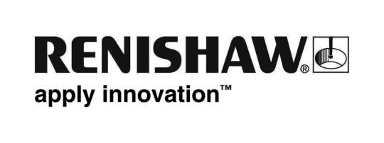
26 May 2017 Enquiries: Ed Littlewood (+44 1453 524530)

Renishaw demonstrates ADEPT software at ADT

Global engineering technologies company, Renishaw, will demonstrate the benefits of its ADEPT software at the Advancing Digital Technology (ADT) Congress meeting, taking place 31st May – 2nd June 2017 in Amiens, France.

Amy Davey, Reconstructive Scientist at North Bristol NHS trust, UK will also hold a Digital Design of Patient Specific Implants (PSI) workshop on Friday 2nd June from 16:00 to 17:00.

During the workshop, Amy will be joined by Alex Harris, an Applications Engineer at Renishaw who will explain how ADEPT can be used to efficiently design implants, which can be additively manufactured helping to improve a hospital’s working practices. The aim of this workshop is to highlight the effectiveness and simplicity of ADEPT and how implants are becoming increasingly accessible to the healthcare market. Surgeons and healthcare professionals can use the software to quickly and easily design bespoke implants, speeding up implant production time.

Renishaw will also exhibit its craniomaxillofacial implants at ADT as well as demonstrating meaningful examples from established work with surgeons and hospitals. The implants are produced from titanium on Renishaw’s additive manufacturing systems, and can be used in a range of procedures such as orbital floor reconstruction and craniectomy.

“Using ADEPT streamlines the production of patient specific implants to make the process simpler and more cost effective, which in turn allows more patients to benefit from custom made implants,” explained Ed Littlewood, Marketing Manager at Renishaw’s Medical and Dental Products Division. “At the ADT Congress, researchers and healthcare professionals will see the potential of this technology and how it is already being successfully applied by surgeons in the NHS and internationally.”

This ADT meeting is hosted by the Facing Faces Institute. The aim of this congress meeting is for professional and industry partners to explore the advanced applications in head and neck reconstruction. Renishaw is a Gold Foundation Industry Partner and Silver Patron of the ADT foundation.

For more information on the ADEPT software, visit http://www.renishaw.com/cmf.

Ends 312 words
Notes to editors
UK-based Renishaw is a world leading engineering technologies company, supplying products used for applications as diverse as jet engine and wind turbine manufacture, through to dentistry and brain surgery. It has over 4,000 employees located in the 35 countries where it has wholly owned subsidiary operations.

For the year ended June 2016 Renishaw recorded sales of £436.6 million of which 95% was due to exports. The company’s largest markets are China, the USA, Japan and Germany.

Throughout its history Renishaw has made a significant commitment to research and development, with historically between 14 and 18% of annual sales invested in R&D and engineering. The majority of this R&D and manufacturing of the company’s products is carried out in the UK.

The Company’s success has been recognised with numerous international awards, including eighteen Queen’s Awards recognising achievements in technology, export and innovation.

Renishaw is listed on the London Stock Exchange (LSE:RSW) where it is a constituent of the FTSE 250, with a current valuation of around £1.8 billion.

Further information at www.renishaw.com

