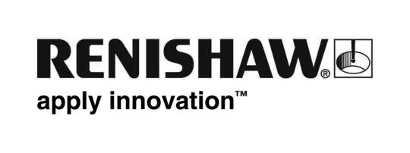
June 2019 Enquiries: Chris Pockett, Head of Communications (+44 1453 524133)

Renishaw invests in Mexico’s manufacturing future
To support its rapidly growing customer base, global engineering technologies company, Renishaw, has opened a new facility in Nuevo León, Mexico. The building, which was formally opened on May 8th, 2019, provides customers with technical support, demonstration and training facilities for the company’s innovative products in metrology, healthcare and additive manufacturing.

Renishaw invested nearly 100 million pesos (5 million US Dollars) in the 3200 m² facility to help manufacturers in Mexico become more efficient and profitable. The new facility has a variety of conference rooms, training rooms, and development labs to allow companies to work with Renishaw engineers to improve efficiency in areas such as metrology, additive manufacturing and motion control. It also has demonstration areas to showcase the latest metrology equipment and process control applications, such as advanced scanning, calibration and gauging systems.

At the inauguration, clients, engineers and press met with Alejandro Silva; Andrew Morris, the British Consulate; Américo García, the Secretary of Industry and Commerce in Nuevo León; and Leo Somerville, President of Renishaw’s Americas region, who all officially opened the facility. After the inauguration, Renishaw hosted a networking event and an Industry 4.0 conference to show visitors how they can collaborate to support industry growth.

“Manufacturing is one of the biggest contributors to Mexico’s economy,” explained Fátima Oyervides, Marketing Manager at Renishaw Mexico. “We originally opened the subsidiary in 2012 and had five employees. Now, to keep up with industry growth in the country, particularly in the automotive and aerospace market, we have grown to a team of 40.”

“As we keep expanding, we will be able to offer more support to local industries. Our facility is not only here to give local support to partners by providing technical help and training; we are also here to educate and support the development of smart manufacturing in Mexico”

Renishaw has provided advanced manufacturing equipment to global partners in the automotive and aerospace industries for over 45 years. This facility in Mexico is one of many Renishaw subsidiaries that are located across 36 countries.

For more information about partnering with Renishaw and understanding more about its advanced equipment, visit www.renishaw.com.

Ends 352 words
Notes to editors
UK-based Renishaw is a world leading engineering technologies company, supplying products used for applications as diverse as jet engine and wind turbine manufacture, through to dentistry and brain surgery. It has over 4,500 employees located in the 36 countries where it has wholly owned subsidiary operations.

For the year ended June 2018 Renishaw recorded sales of £611.5 million of which 95% was due to exports. The company’s largest markets are China, the USA, Germany and Japan.

Throughout its history Renishaw has made a significant commitment to research and development, with historically between 13 and 18% of annual sales invested in R&D and engineering. The majority of this R&D and manufacturing of the company’s products is carried out in the UK.

The Company’s success has been recognised with numerous international awards, including eighteen Queen’s Awards recognising achievements in technology, export and innovation.

Further information at http://www.renishaw.com/

