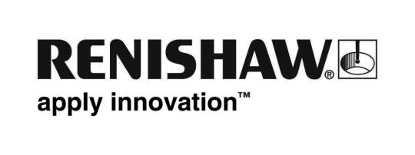
April 2018 Enquiries: Chris Pockett, Head of Communications (+44 1453 524133)

Renishaw supports UK and India business ties
On April 19th, 2018, Rhydian Pountney, Managing Director of Renishaw UK Sales Limited, attended the Access India event as part of the Make in India initiative. Set alongside a backdrop of the Commonwealth Heads of Government Meeting in London, UK, the event gave British small and medium enterprises (SMEs) the opportunity to meet with large manufacturing businesses and government representatives, to facilitate bilateral investment and help SMEs to set up Indian manufacturing operations.

The Make in India initiative was launched by Prime Minister Narendra Modi in September 2014 to strengthen the Indian design and manufacturing industries. The Access India Programme (AIP) is a newly launched scheme, specifically aimed at innovative SMEs in the UK, which forms part of the Make in India Initiative. Led by India’s Department of Industrial Policy and Promotion (DIPP), the programme is run in conjunction with the Indian High Commission in London and the UK India Business Council (UKIBC).

The first event, hosted at Buckingham Gate, was attended by Mr Ramesh Abhishek, Secretary of the DIPP, who was introduced to major UK investors in India and SMEs on the AIP. Companies in attendance included Renishaw, BAE Systems, Rolls Royce, JCB, Perkins Engines and TVS Supply Chain Solutions.

At the event, Renishaw presented Mr Ramesh Abhishek with a stainless steel, 3D printed Make in India logo to commemorate the day and showcase Renishaw’s Additive Manufacturing Solutions Centre in Pune, India. As part of his role, Rhydian Pountney acts as a mentor for the first 24 SMEs selected for the AIP programme, offering support and advice on how to set up operations in India.

“Trade between India and the UK is on the rise,” explained Pountney. “Leading this trend are large, multinational companies. To facilitate stronger trade links and increased UK investment in India, the AIP encourages SMEs to learn from the successes of multinationals with a long-standing, established presence in India.

“This allows UK SMEs to access the benefits of opening facilities in India,” continued Pountney. “India offers a strong technical skill base, one of the fastest growing economies and a good location to export to the rest of Asia and beyond.”

Renishaw has been trading in India for more than 30 years and created a wholly owned subsidiary in Bangalore in 2000. The company now employs over 400 people across five offices, which includes a manufacturing facility, R&D operations and an Additive Manufacturing Solutions Centre. For more information on Renishaw visit www.renishaw.com.

Ends 382 words
Notes to editors
UK-based Renishaw is a world leading engineering technologies company, supplying products used for applications as diverse as jet engine and wind turbine manufacture, through to dentistry and brain surgery. It has over 4,000 employees located in the 35 countries where it has wholly owned subsidiary operations.

For the year ended June 2017 Renishaw recorded sales of £536.8 million of which 95% was due to exports. The company’s largest markets are China, the USA, Japan and Germany.

Throughout its history Renishaw has made a significant commitment to research and development, with historically between 14 and 18% of annual sales invested in R&D and engineering. The majority of this R&D and manufacturing of the company’s products is carried out in the UK.

The Company’s success has been recognised with numerous international awards, including eighteen Queen’s Awards recognising achievements in technology, export and innovation.

Further information at www.renishaw.com.

