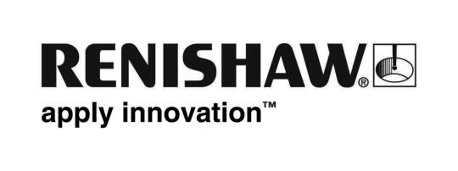
June 2018 Enquiries: Chris Pockett, Head of Communications (+44 1453 524133)

Renishaw apprentices inspire a new generation of engineers at MACH 2018
55 apprentices from global engineering technologies company Renishaw volunteered at MACH 2018 to support the Education and Development Zone. The initiative, run by the Manufacturing Technologies Association (MTA), involved tours, talks and demonstrations at the show to encourage students aged eleven to 19 to study science, technology, engineering and maths (STEM) subjects at a higher level.

The MTA organises apprentice-led guided tours around the exhibition for students and families to show how modern and high-tech the manufacturing industry is, and to change outdated opinions about the sector.

Renishaw was one of the many companies that volunteered apprentices to become tour guides at MACH. The apprentices took students on a tour of the show, where exhibitors gave talks, demonstrations, or organised hands-on activities to educate students about what is happening in the industry and the many paths in to engineering.

“Taking apprentices to exhibitions like MACH benefits visiting students and their families,” explained Chris Pockett, Head of Communications at Renishaw. “The apprentices offer another perspective to the exhibitors, as they are only a few years older. Our apprentices can relate to the students and give advice and tips on the paths into engineering and what the job is really like.

“The initiative also helps apprentices to improve their skills,” added Pockett. “Conducting tours aids their personal development, improves their communication skills and helps them to contextualise their knowledge.”

“Companies like Renishaw are leading the way in inspiring the next generation of engineers,” explained Laura Pickering, Education & Development Manager at the MTA. “The company offers a fantastic apprenticeship programme, providing young people a route into a high-flying engineering career. Renishaw has done a lot to increase the uptake of engineering in further education by offering an extensive education outreach scheme.”

Apprentices attending included Steven Pickles, a Production Technician at Renishaw’s Miskin site near Cardiff, who was named Apprentice of the Year at the Apprentice Awards Cymru 2017. As well as MACH, Renishaw’s apprentices get involved with other initiatives to inspire students to study STEM subjects, such as Greenpower. Over 130 of Renishaw’s staff are STEM ambassadors, who visit local primary and secondary schools to support the national curriculum for STEM subjects.

For more information on routes into engineering careers and how you can get involved with Renishaw’s education outreach programme, visit http://www.renishaw.com/en/careers--6417.

Ends 382 words
Notes to editors
UK-based Renishaw is a world leading engineering technologies company, supplying products used for applications as diverse as jet engine and wind turbine manufacture, through to dentistry and brain surgery. It has over 4,000 employees located in the 35 countries where it has wholly owned subsidiary operations.

For the year ended June 2017 Renishaw recorded sales of £536.8 million of which 95% was due to exports. The company’s largest markets are China, the USA, Japan and Germany.

Throughout its history Renishaw has made a significant commitment to research and development, with historically between 14 and 18% of annual sales invested in R&D and engineering. The majority of this R&D and manufacturing of the company’s products is carried out in the UK.

The Company’s success has been recognised with numerous international awards, including eighteen Queen’s Awards recognising achievements in technology, export and innovation.

Further information at www.renishaw.com

