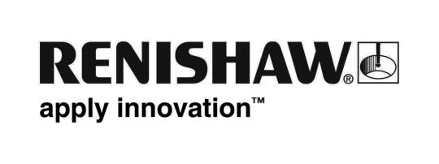
September 2018 Enquiries: Chris Pockett, Head of Communications (+44 1453 524133)

Renishaw takes education outreach programme to IMTS 2018
To inspire students to pursue a career in advanced technology, global engineering technologies company Renishaw is attending the IMTS Smartforce Student Summit from September 10th to 15th 2018 at McCormick Place, Chicago, USA. Renishaw will exhibit to young people, parents and teachers from a dedicated education booth as well as hosting Learning Labs on an adjacent booth. The education programme forms part of Renishaw’s larger presence at IMTS 2018, which focusses on automated process control and additive manufacturing.

Renishaw’s education booth can be found in Hall C, booth 215215 and its Learning Labs will be hosted on booth 215112.

Visitors to the Renishaw education booth will be introduced to the Equator™ 300 versatile gauge, a unique, reconfigurable measurement system for the inspection of high volume manufacturing parts. To further educate attendees on the technology available for measurement, the company will also showcase a selection of its machine tool inspection probes and tool setters.

To give visitors an understanding of metal additive manufacturing, the company will exhibit a demonstration machine of the new RenAM 500Q, a four-laser system. The machine will be showcased alongside 3D printed metal parts for the BLOODHOUND SSC, a supersonic car designed to set a new land speed record.

Renishaw will also host two Learning Labs each day, where teachers and college and university students can learn about metal additive manufacturing (AM) and the Equator™ gauge. One session will focus on high speed inspection of National Institute for Metalworking Skills (NIMS) parts against master parts using the Equator™ gauge. The other session will introduce attendees to the powder bed fusion metal additive manufacturing process. Teachers that attend a Learning Lab will be awarded a certificate towards their professional development.

“The skills shortage in manufacturing is a global problem that can only be addressed with a combined, ongoing effort,” explained Lucy Ackland, Applications Development Senior Project Manager at Renishaw. “At the Smartforce Student Summit at IMTS, Renishaw will use its equipment in technical training to promote careers in advanced technology to a wide audience. We hope the show changes the perception of manufacturing careers, making them attractive to the young people attending.

“Renishaw is committed to supporting manufacturing training in the US,” added Ackland. “Renishaw supports colleges by offering technical training materials and products specifically for education purposes, including the Equator gauging system for the inspection of NIMS level one parts.”

The IMTS Smartforce Student Summit is hosted at IMTS to inspire students to pursue a career in advanced technology. The 2018 Summit is focussed on ‘manufacturing brighter futures’ and highlights a number of cutting edge technologies and concepts including additive manufacturing, metrology and smart manufacturing. The summit helps connect science, technology, engineering and maths (STEM) learning with careers in manufacturing technology, by giving students access to high-tech tools and equipment.

To register for one of Renishaw’s Learning Labs at IMTS, visit www.imts.com/student.

Ends 447 words
Notes to editors
UK-based Renishaw is a world leading engineering technologies company, supplying products used for applications as diverse as jet engine and wind turbine manufacture, through to dentistry and brain surgery. It has over 4,500 employees located in the 36 countries where it has wholly owned subsidiary operations.

For the year ended June 2018 Renishaw recorded sales of £611.5 million of which 95% was due to exports. The company’s largest markets are China, the USA, Germany and Japan.

Throughout its history Renishaw has made a significant commitment to research and development, with historically between 13 and 18% of annual sales invested in R&D and engineering. The majority of this R&D and manufacturing of the company’s products is carried out in the UK.

The Company’s success has been recognised with numerous international awards, including eighteen Queen’s Awards recognising achievements in technology, export and innovation.

Further information at www.renishaw.com

