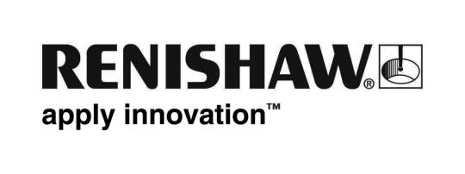
March 2018 Enquiries: Chris Pockett, Head of Communications (+44 1453 524133)

Renishaw encourages uptake of STEM with FDC launch

Global engineering technologies company Renishaw will officially launch its Fabrication Development Centre (FDC) on March 28th, 2018 at the company’s Miskin facility in South Wales. On the day, Renishaw will also launch its education partnership with BLOODHOUND SSC. To celebrate this, Andy Green OBE, current holder of the World Land Speed Record and BLOODHOUND SSC driver, will open the facility.

The FDC is a unique educational resource for hands-on learning. It aims to inspire young people and to encourage a pipeline of talent into science, technology, engineering and maths (STEM) careers. Schools or groups of young people can use the facility for free for lessons or workshops. The FDC contains two classrooms, staffed by a qualified teacher and Renishaw’s STEM ambassadors. It is equipped with state-of-the-art equipment, including 3D printers.

“With companies already struggling to recruit skilled candidates, it is important to get more young people interested in STEM subjects at GCSE and A-Level,” explained Simon Biggs, Education Outreach Officer at Renishaw. “Creating engaging educational experiences for pupils at a young age can be essential to their selection of the subject at degree or apprenticeship level.

“The Fabrication Development Centre not only gives pupils a chance to escape the classroom, but it also enables them to grasp the link between the school curriculum and industry. They can take part in motivating workshops that complement the exam specification and give them a better understanding of the career opportunities available to them in the future.”

Large numbers of young people have already experienced success from using the facility, including students at Radyr Comprehensive. After using the FDC for just a few months, the school noticed increased motivation among the pupils. Radyr Comprehensive School now plans to extend its use of the facility across the three years of its GCSE programme to increase the interest and uptake of design subjects.

Schools in the Bristol, Gloucestershire and South Wales areas can access an online booking form from the education outreach section of Renishaw’s website. Here, schools, pupils and teachers can also find more information on Renishaw’s work with young people and engineering careers advice - http://www.renishaw.com/en/education-outreach--34713.

Ends 353 words
Notes to editors
UK-based Renishaw is a world leading engineering technologies company, supplying products used for applications as diverse as jet engine and wind turbine manufacture, through to dentistry and brain surgery. It has over 4,000 employees located in the 35 countries where it has wholly owned subsidiary operations.

For the year ended June 2017 Renishaw recorded sales of £536.8 million of which 95% was due to exports. The company’s largest markets are China, the USA, Japan and Germany.

Throughout its history Renishaw has made a significant commitment to research and development, with historically between 14 and 18% of annual sales invested in R&D and engineering. The majority of this R&D and manufacturing of the company’s products is carried out in the UK.

The Company’s success has been recognised with numerous international awards, including eighteen Queen’s Awards recognising achievements in technology, export and innovation.

Further information at www.renishaw.com

