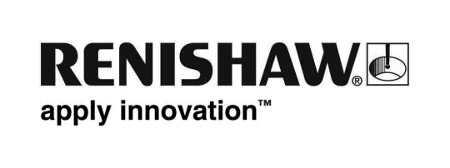
July 2019 Enquiries: Chris Pockett, Head of Communications (+44 1453 524133)

Renishaw supports Brunel Racing in Formula Student competition
Global engineering technologies company, Renishaw, is supporting the Brunel University London race team in its 20th year participating in the Formula Student (FS) competition. Renishaw is contributing its metal additive manufacturing (AM) expertise to help Brunel Racing create a manifold part for the team’s BR-XX car, which will be used to compete at FS-UK in Silverstone and FS-ATA in Italy in July.

Formula Student, which has existed for over 20 years, is Europe's most established educational motorsport competition, run in the UK by the Institution of Mechanical Engineers (IMechE). Prior to working with Renishaw, the Brunel Racing team had produced carbon fibre and aluminium fabricated manifolds, but this method had limitations due to the design geometry. This year, the team worked on a more ambitious design including additional features such as dual stage fuel injection and improved port matching between exhaust manifold and the engine to increase efficiency.

Brunel Racing provided Renishaw with the original design geometry for the manifold part and then worked with the company to optimise the part for production on its multi-laser RenAM 500Q AM system. This included splitting the part into smaller assemblies and looking at how to eliminate overhangs where possible.

“Renishaw’s expertise and advice on how to design a part for the additive manufacturing process was invaluable,” explained Matthew Crouch, a Mechanical Engineering student and one of the managers of theBrunel Racing team. “To design for AM, overhangs could not be over 55° from the vertical axis on both overhangs and each part requires smooth transitions of cross sectional thickness.”

“Additive manufacturing proved itself to be a much more suitable manufacturing method than a traditional approach,” added Crouch. “The final part performs better in the car due to its increased strength and we also had the added benefit of reduced post processing.”

“The applications of AM are broadening into ever more industries,” explained Joshua Whitmore, Applications Engineer at Renishaw. “In many examples, it offers clear benefits over traditional manufacturing methods as you can simplify the manufacturing process or increase part performance. The growing use of multi-laser machines, such as the RenAM 500Q, allows for higher build rates, vastly improving productivity and lowering cost per part.”

Renishaw’s additive manufacturing technology has been used in a diverse range of sporting and racing applications. The company is working with INEOS TEAM UK in its bid to bring the America’s Cup home to Britain. Renishaw is also supporting Atherton Bikes, a new mountain bike brand, set up by the World-Championship winning Atherton family.

To find out how additive manufacturing could streamline your manufacturing processes or improve the performance of your part visit www.renishaw.com/additive.

Ends 443 words
Notes to editors
UK-based Renishaw is a world leading engineering technologies company, supplying products used for applications as diverse as jet engine and wind turbine manufacture, through to dentistry and brain surgery. It has over 4,500 employees located in the 36 countries where it has wholly owned subsidiary operations.

For the year ended June 2018 Renishaw recorded sales of £611.5 million of which 95% was due to exports. The company’s largest markets are China, the USA, Germany and Japan.

Throughout its history Renishaw has made a significant commitment to research and development, with historically between 13 and 18% of annual sales invested in R&D and engineering. The majority of this R&D and manufacturing of the company’s products is carried out in the UK.

The Company’s success has been recognised with numerous international awards, including eighteen Queen’s Awards recognising achievements in technology, export and innovation.

Further information at www.renishaw.com

