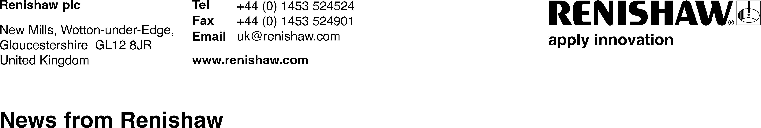

October 2025 – for immediate release

Renishaw to showcase end-to-end additive manufacturing workflow at Formnext 2025

Renishaw, a global leader in precision engineering and additive manufacturing (AM), will unveil its latest AM innovations at Formnext 2025, taking place from November 18 to 21 in Frankfurt, Germany. At stand C11 in hall 11, Renishaw will present a production-focused showcase under the theme: “From Print to Precision: Productivity Upgraded.”, showcasing high-productivity additive manufacturing workflows for diverse applications including the production of microturbines for propulsion and energy generation.

At the heart of the showcase is LIBERTAS, Renishaw’s new software that opens unprecedented access to laser parameter tuning. LIBERTAS addresses two of the most persistent challenges in metal AM: poor downskin surface finish and the need for support structures. While traditional supports manage heat and distortion, they increase material usage, extend build times and require costly post-processing. Unlike conventional workflows, LIBERTAS dynamically adjusts scan parameters across different sections of a part, enabling engineers to print complex geometries with smoother downskin surfaces and without supports. This also results in reduced waste and higher-quality finishes, maximising AM’s productivity without the need for costly hardware upgrades.

Also on the stand will be a new long-life filtration system, purpose-built for Renishaw’s RenAM 500 series of metal additive manufacturing systems. The new system delivers continuous gas-flow filtration for uninterrupted production. Designed to safely remove condensate and particulate by-products generated during the build process, the system allows for months of operation without intervention. Fully compatible with RenAM 500 S (single laser), D (dual laser) and Q (four laser) configurations, the long-life filtration system maximises machine uptime, reduces labour and disposal costs and ensures reliable performance in demanding production environments.

“Visitors will see a complete production cell featuring a Renishaw RenAM 500 Ultra system with TEMPUS™ technology, a Chiron Micro 5XL and Renishaw's new Equator-X™ dual-method gauging system, providing an end-to-end process flow: printing, milling and inspection”, said Chris Dimery, Additive Manufacturing EMEA Business Manager at Renishaw. “On this cell, there will be a nozzle guided vane (NVG), enabled by LIBERTAS, the Chiron machining critical features, and the Equator-X system performing part inspection. This illustrates a practical workflow that builds upon Renishaw’s advance manufacturing knowledge, showing users what is possible when you work with the right partner.”

Renishaw will also feature advanced microturbines from Argive, a recent spin-off of UK metal manufacturing specialists Alloyed, showcasing the potential of AM for high-performance propulsion applications. The A300 microturbine is already incorporated in drone applications, whilst the A1100 microturbine is additively manufactured using Alloyed’s nickel superalloy ABD-900AM, which is engineered for high-temperature performance and durability.

“To complement our on-stand production cell, Renishaw will present alongside Siemens Digital Industries Software in a joint session to showcase a fully integrated additive manufacturing workflow designed to deliver optimised, integrated blade rotors for aerospace and defence applications,” added Dimery. “Using Siemens’ digital twin technologies combined with Renishaw’s precision metal AM systems, advanced toolpaths and post-process metrology. The session will demonstrate a seamless, data-driven pathway from digital design intent to certifiable parts for next-generation platforms.”

Renishaw invites visitors to discover these innovations at stand C11 in hall 11 Messe Frankfurt, and learn more about its AM solutions. For further information on Renishaw’s additive manufacturing offering, visit www.renishaw.com/en/metal-3d-printing.

-ENDS-

Notes to editors

About Renishaw
Renishaw is a world leader in measuring systems and manufacturing systems. Its products give high accuracy and precision, gathering data to give customers and end users traceability and confidence in what they’re making. This technology also helps its customers to innovate their products and processes.

It is a global business with over 5,000 employees located in the 36 countries where it has wholly owned subsidiary operations. The majority of R&D work takes place in the UK, with the largest manufacturing sites located in the UK, Ireland and India.

For the year ended June 2025 Renishaw recorded sales of £713.0 million of which 95% was due to exports. The company’s largest markets are China, USA, Japan and Germany.

Renishaw is guided by its purpose: Transforming Tomorrow Together. This means working with its customers to make the products and materials that will define our world in the decades to come, and touch billions of lives.

Further information at www.renishaw.com

