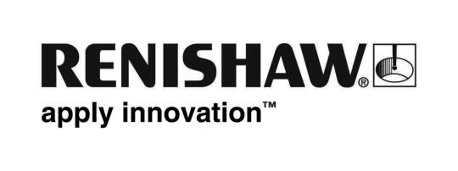
November 2017 Enquiries: Chris Pockett, Head of Communications (+44 1453 524133)

Renishaw strengthens education outreach programme

To support its popular education outreach programme, global engineering technologies company, Renishaw, has launched a new dedicated section of its website. Aimed at parents, teachers and school students in South Gloucestershire, Bristol and South Wales, the area gives information about its on-site workshops and educational facilities, which aim to get young people involved in engineering. The pages also include engineering careers information, an online booking form and engineering careers ‘mythbusting’. The pages can be accessed online here.

Renishaw works with local schools, universities and partners to promote a positive view of engineering careers to young people. As a part of this, the company offers a range of activities including hands-on practical sessions, work experience, careers talks and tours of its world class facilities.

The new web pages offer an online booking form for schools in South Wales, Bristol and Gloucestershire to attend Renishaw for a range of workshops. These take place either at the company’s Wotton-under-Edge headquarters or a dedicated education facility at its Miskin manufacturing plant.

The education outreach pages also contains information aimed at young people, which is designed to interest and educate them about careers in engineering. This includes information on what engineering is and what a career in engineering entails, as well as the pathways into the field. Students can also find out more about the company’s work experience programme and how to get involved.

“Before adding the pages, we had a very limited education outreach information on our website,” explained Simon Biggs, Education Outreach Officer at Renishaw. “Local schools found out about the work we do by word of mouth. Having the section online will increase the number of people who can find out about our outreach programme and help us to interact with new schools, universities and partners, spreading our positive message among more young people.”

“We are working hard to show young people that engineering is a fun, engaging and successful career pathway,” explained Chris Pockett, Head of Communications at Renishaw. “Each of our workshops link to the school curriculum to help young people understand how what they are doing in school can be applied to the wider industry and career opportunities. This promotes engineering in a positive light, by creating a meaningful experience early on.”

Renishaw works with a number of partners to help promote its education outreach messages including Aerospace Bristol, Festomane, SS Great Britain Trust, Bristol Music Trust, The Engineering Education Scheme Wales and Greenpower.

For more information on Renishaw’s education outreach, visit http://www.renishaw.com/en/education-outreach--34713.

Ends 404 words
Notes to editors
UK-based Renishaw is a world leading engineering technologies company, supplying products used for applications as diverse as jet engine and wind turbine manufacture, through to dentistry and brain surgery. It has over 4,000 employees located in the 35 countries where it has wholly owned subsidiary operations.

For the year ended June 2017 Renishaw recorded sales of £536.8 million of which 95% was due to exports. The company’s largest markets are China, the USA, Japan and Germany.

Throughout its history Renishaw has made a significant commitment to research and development, with historically between 14 and 18% of annual sales invested in R&D and engineering. The majority of this R&D and manufacturing of the company’s products is carried out in the UK.

The Company’s success has been recognised with numerous international awards, including eighteen Queen’s Awards recognising achievements in technology, export and innovation.

Further information at www.renishaw.com

