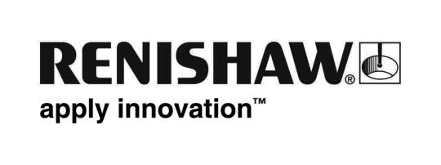
December 2017 Enquiries: Chris Pockett, Head of Communications (+44 1453 524133)

A year of success with Radyr Comprehensive School
Global engineering and scientific technologies company, Renishaw, is celebrating a successful year of its education outreach partnership with Radyr Comprehensive School. Students from the school, local to the company’s South Wales Miskin facility, have been using Renishaw’s Fabrication Development Centre (FDC) as part of their product design lessons. Following a successful first year, the school has now taken on its largest ever cohort of product design students.
The FDC is an educational resource that schools or groups can use for free for lessons or workshops. The aim of the facility is to develop engineering talent in Welsh schools, in order to secure a strong talent pool of engineers for the future. The FDC contains two classrooms, staffed by a qualified teacher and science, technology, engineering and maths trained Renishaw ambassadors. It is equipped with state of the art equipment, including 3D printers.
Radyr Comprehensive School is the first school to timetable regular lessons at Renishaw. From September 2016, pupils from the school’s year nine GCSE class and year twelve A Level class have made regular visits to Renishaw as part of their product design lessons. The students have been able to contextualise their learning from the school curriculum in a manufacturing environment.
“The projects the students worked on were supported by engineers to complement the school curriculum,” explained Simon Biggs, Education Outreach Officer at Renishaw, “We specifically tailored the projects so that the students were able to find a clear link between the school curriculum and its industrial applications. This can be a key step in overcoming the stereotypes and opening young people’s eyes to what a career in engineering actually involves.”
“Last year, every Radyr Comprehensive School student who used the FDC passed product design,” explained Richard Jenkins, Assistant Headteacher at Radyr Comprehensive School. “What’s more, the buzz created by using the latest tech has definitely travelled around the school – we have just taken on the largest ever cohort of product design students.”
“Choosing relevant GCSE and A level subjects is crucial for encouraging young people into engineering careers,” continued Jenkins. “Across the UK, design and technology numbers are dwindling, but thanks to Renishaw, we’re actually experiencing the opposite at Radyr Comprehensive School.”
Following the first year, the school has renewed its partnership with Renishaw and plans to increase numbers visiting the facility. For more information on Renishaw, or to find out how you can get involved at the FDC, visit www.renishaw.com/educationoutreach.
Ends 403 words
Notes to editors
UK-based Renishaw is a world leading engineering technologies company, supplying products used for applications as diverse as jet engine and wind turbine manufacture, through to dentistry and brain surgery. It has over 4,000 employees located in the 35 countries where it has wholly owned subsidiary operations.

For the year ended June 2017 Renishaw recorded sales of £536.8 million of which 95% was due to exports. The company’s largest markets are China, the USA, Japan and Germany.

Throughout its history Renishaw has made a significant commitment to research and development, with historically between 14 and 18% of annual sales invested in R&D and engineering. The majority of this R&D and manufacturing of the company’s products is carried out in the UK.

The Company’s success has been recognised with numerous international awards, including eighteen Queen’s Awards recognising achievements in technology, export and innovation.

Further information at www.renishaw.com

