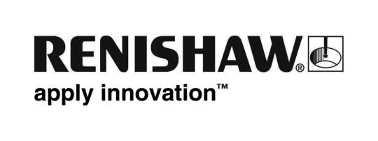
February 2019 Enquiries: Chris Pockett, Head of Communications (+44 1453 524133)

Renishaw sponsors STEMworks K’NEX workshops to inspire the next generation of Engineers

To improve science, technology, engineering and maths (STEM) engagement in primary schools across Gloucestershire, global engineering technologies company Renishaw is sponsoring a local not-for-profit company STEMworks to deliver 100 workshops with students aged nine to eleven to inspire the next generation of engineers.

During these sessions, STEMworks will talk about what engineering is, what engineers do and then students have the opportunity to think like engineers as they participate in a K’NEX competition in the classroom increasing STEM-related skills such as problem solving, teamwork and following a technical brief.

At each session, a class is given a brief and one hour to build a machine using creative building toys, K’NEX. The sessions are often supported by Renishaw STEM Ambassadors who help the students understand how they can design, build and test their ideas. This also gives the students role models from the engineering industry, which will hopefully encourage them to pursue a career in this field in the future.

“Hands-on activities, such as the K’NEX competition, are an exciting and effective way of engaging and developing future engineers,” explained Oliver Jelley, Industrial Placement Engineer at Renishaw who recently supported a workshop. “This competition gives students an insight into the skills needed to be an engineer and allows them to feel proud of their final designs.”

“We have the opportunity to influence over 3,000 students by running 100 workshops at schools across Gloucestershire,” explained Rebecca Bound, Education Outreach Officer at Renishaw. “It can be challenging for schools to deliver engaging workshops if they are limited by the curriculum or a lack of resources. The collaboration between Renishaw and STEMworks means that we can work with more schools to deliver exciting activities that contextualise engineering and encourage students to consider studying STEM subjects at a higher level.”

Renishaw offers an extensive education outreach programme to support primary and secondary schools across Bristol, Gloucestershire and South Wales. Renishaw also partners with local initiatives such as the Bristol Music Trust, local Brownie groups and Cheltenham Science Festival to engage with more students and help them understand more about STEM subjects.

For more information about Renishaw’s education outreach programme, visit http://www.renishaw.com/education-outreach.

Ends 356 words
Notes to editors
UK-based Renishaw is a world leading engineering technologies company, supplying products used for applications as diverse as jet engine and wind turbine manufacture, through to dentistry and brain surgery. It has over 4,500 employees located in the 36 countries where it has wholly owned subsidiary operations.

For the year ended June 2018 Renishaw recorded sales of £611.5 million of which 95% was due to exports. The company’s largest markets are China, the USA, Germany and Japan.

Throughout its history Renishaw has made a significant commitment to research and development, with historically between 13 and 18% of annual sales invested in R&D and engineering. The majority of this R&D and manufacturing of the company’s products is carried out in the UK.

The Company’s success has been recognised with numerous international awards, including eighteen Queen’s Awards recognising achievements in technology, export and innovation.

Further information at http://www.renishaw.com/

