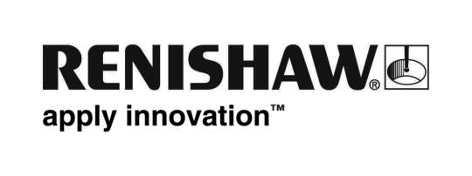
September 2017 Enquiries: Chris Pockett, Head of Communications (+44 1453 524133)

Renishaw supports dental care charity

Global engineering technologies company, Renishaw, is a bronze corporate partner of Bridge2Aid. The charity trains healthcare professionals in rural areas of developing countries to provide them with new skills in emergency dentistry and oral health. This year Renishaw’s sponsorship part-funded the training of a clinical officer, who is now providing dental care to 10,000 people who previously had been without access to a dentist.

Bridge2Aid was founded in 2004 to improve the training of health workers in rural areas of East Africa, where a lack of access to basic emergency dental care is a serious problem. In the developed world, there is one dentist for every 2,000 people. In contrast, in Africa, there is one dentist for every 150,000.

Dental pain can be debilitating, but visiting a dentist is not a possibility for everyone. Over 110 million people in East Africa have no or limited access to emergency dental care. Those with dental pain may suffer for months and years, which could impact their work, health and family life. Dental infections can even be life threatening. The training programme was developed in response to this recognised need.

Bridge2Aid’s training programme involves volunteers from the UK dental community visiting rural health workers in Tanzania to embed new skills into the primary health care system. The training covers emergency dental care and how to deliver oral health education to people in the community. After completing the course, the clinical officer is then able to provide care and treatment to their local communities using a kit provided by the charity.

Volunteers train clinical officers to use appropriate methods for the clinics they work in, which may be without running water or electricity. The main focus is on tooth extraction, which is often the best way to treat those suffering with dental pain.

“Over 70 per cent of the world’s population doesn’t have access to a dentist,” explained Ed Littlewood, Marketing Manager at Renishaw’s Medical and Dental Products Division. “Renishaw has been a bronze sponsor of the charity since 2014 to help change this. Bridge2aid’s training has a long-term impact on rural communities to decrease infection and reduce dental pain, strengthening local healthcare systems and providing more people access to safe dental care.”

“It is essential that Bridge2aid has corporate support – without it we wouldn’t be able to deliver our training programme,” explained Kerry Shillito, Fundraising Executive at Bridge2Aid. “Each year Renishaw’s support helps us fund the training of a rural health worker in Tanzania, which impacts a community of 10,000 people, helping free them from dental pain and have improved oral health.”

Renishaw is a leading supplier of dental products designed and manufactured in house, including scanners, software and additive manufacturing machines. To find out more about Renishaw’s dental products, visit www.renishaw.com/dental.

Ends 461 words
Notes to editors
UK-based Renishaw is a world leading engineering technologies company, supplying products used for applications as diverse as jet engine and wind turbine manufacture, through to dentistry and brain surgery. It has over 4,000 employees located in the 35 countries where it has wholly owned subsidiary operations.

For the year ended June 2017 Renishaw recorded sales of £536.8 million of which 95% was due to exports. The company’s largest markets are China, the USA, Japan and Germany.

Throughout its history Renishaw has made a significant commitment to research and development, with historically between 14 and 18% of annual sales invested in R&D and engineering. The majority of this R&D and manufacturing of the company’s products is carried out in the UK.

The Company’s success has been recognised with numerous international awards, including eighteen Queen’s Awards recognising achievements in technology, export and innovation.

Further information at www.renishaw.com

