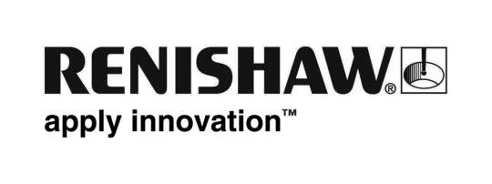
June 2018 Enquiries: Chris Pockett, Head of Communications +44 (0)1453 524133

Renishaw showcases neuro-oncology solutions at ISPNO
Renishaw, a global engineering company with expertise in healthcare, is exhibiting at the International Symposium on Paediatric Neuro-Oncology (ISPNO) 2018. From June 30th to July 3rd at the Hyatt Regency Hotel in Denver, Colorado, USA the company will showcase its neurological products which improve accuracy and reduce procedure time in neurosurgery.

The 2018 meeting marks the 18th year of ISPNO, which has become the leading event for advancing clinical and translational research with technical advances for infants, children and adolescents with central nervous system tumours. The symposium includes an education day for junior staff and trainees, a neurosurgical programme and a programme for neuro-oncology nurses.

At the symposium, Renishaw will highlight the benefits of the neuromate® a stereotactic robot for a broad range of neurosurgical procedures, including biopsies. The neuromate robot can be used to establish a histological diagnosis with minimal risks, without the use of a stereotactic frame. This expands the possible trajectories into the brain to improve access to lesions in the brain.

Visitors will also be introduced to the neuroinfuse™ drug delivery system, a device currently only available for use in approved clinical trials. The investigational device allows intraparenchymal drug delivery, which bypasses the blood brain barrier and shows promise in providing a step change in treating neurological conditions. Renishaw is seeking academic, clinical and industrial partners interested in treating neuro-oncology and neurodegenerative diseases.

“Communicating technological advancements to the international neuro-oncology community is essential in enhancing patient care,” explained Stuart Campbell, Clinical Sales Development Manager at Renishaw. “ISPNO provides a forum for open discussion and knowledge sharing or the latest research and developments, which ultimately will allow the industry to progress and impact children’s lives.”

Renishaw is developing a range of engineering solutions for the diagnosis and treatment of neurological diseases. For more information visit http://www.renishaw.com/en/neurological-products-and-therapies--6332.

Ends 299 words
Notes to editors
UK-based Renishaw is a world leading engineering technologies company, supplying products used for applications as diverse as jet engine and wind turbine manufacture, through to dentistry and brain surgery. It has over 4,500 employees located in the 35 countries where it has wholly owned subsidiary operations.

For the year ended June 2017 Renishaw recorded sales of £536.8 million of which 95% was due to exports. The company’s largest markets are China, the USA, Japan and Germany.

Throughout its history Renishaw has made a significant commitment to research and development, with historically between 14 and 18% of annual sales invested in R&D and engineering. The majority of this R&D and manufacturing of the company’s products is carried out in the UK.

The Company’s success has been recognised with numerous international awards, including eighteen Queen’s Awards recognising achievements in technology, export and innovation.

Further information at www.renishaw.com

