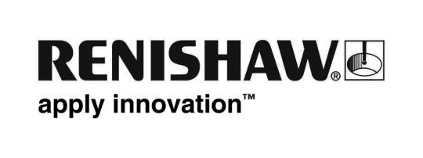
November 2018 Enquiries: Chris Pockett, Head of Communications (+44 1453 524133)

Renishaw renews sponsorship of Gloucester-Hartpury Women
To continue to challenge gender stereotypes in engineering and rugby, global engineering company Renishaw has extended its partnership with Gloucester-Hartpury Women’s Rugby Football Club (WRFC). Renishaw has long supported Gloucester Rugby’s initiatives as a community and has sponsored Gloucester men’s and England international rugby union player, Ben Morgan, since 2012.

The Gloucester-Hartpury women’s sponsorship deal means that Renishaw’s logo will be featured on the team’s kit. The company will also have signs at Kingsholm stadium and contribute to a new digital content project.

Renishaw’s extended support of Gloucester Rugby builds on previous joint community initiatives with the club, including a free rugby open day for girls aged ten to 18, where attendees were introduced to opportunities in both rugby and engineering.

Women’s rugby is one of the fastest growing female sports, with 30,000 women now playing regularly at a club — twice as many as in 2014. After this rapid growth, women now make up a quarter of total players worldwide.

“Renishaw is committed to developing skills in the Gloucester region, both in rugby and in engineering,” explained Chris Pockett, Head of Communications at Renishaw. “We successfully recruit a large number of apprentices and graduates from the region and run an extensive education outreach programme to encourage young people, particularly girls, to consider engineering as a career.

“Engineering draws an interesting parallel to rugby, which is typically seen as a male sport,” added Pockett. “Renishaw wants to challenge social stereotypes and the perception that engineering and rugby are only for men.”

“Renishaw is a fantastic business for us to be in partnership with,” explained Adam Benson Chief Commercial Officer at Gloucester Rugby. “It is great to see that it shares our vision for both the club and for women’s rugby”.

For more information on Renishaw’s education outreach programme, visit www.renishaw.com/education.

Ends 301 words
Notes to editors
UK-based Renishaw is a world leading engineering technologies company, supplying products used for applications as diverse as jet engine and wind turbine manufacture, through to dentistry and brain surgery. It has over 4,500 employees located in the 36 countries where it has wholly owned subsidiary operations.

For the year ended June 2018 Renishaw recorded sales of £611.5 million of which 95% was due to exports. The company’s largest markets are China, the USA, Germany and Japan.

Throughout its history Renishaw has made a significant commitment to research and development, with historically between 13 and 18% of annual sales invested in R&D and engineering. The majority of this R&D and manufacturing of the company’s products is carried out in the UK.

The Company’s success has been recognised with numerous international awards, including eighteen Queen’s Awards recognising achievements in technology, export and innovation.

Further information at http://www.renishaw.com/

