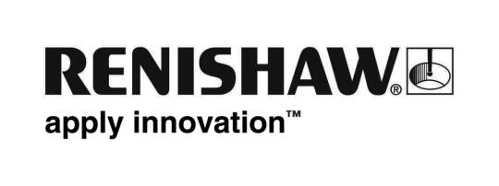
08/01/2018 Enquiries: Chris Pockett, Head of Communications (+44 1453 524133)

Trailblazer Renishaw to take part in award-winning arts trail featuring Aardman characters in Bristol

After the success of the Gromit Unleashed and Shaun in the City trails, global engineering technologies company, Renishaw, is taking part in the third, upcoming trail organised by Bristol Children’s Hospital charity, Wallace & Gromit’s Grand Appeal. The public arts trail will return to Bristol from Monday July 2nd to Sunday September 2nd, 2018 and will feature over 60 sculptures to raise money for Bristol Children’s Hospital and the Special Care Baby Unit at St Michael’s Hospital.

The third trail will feature the famous Aardman duo, Wallace and Gromit and their arch nemesis from The Wrong Trousers, Feathers McGraw. The Grand Appeal is working with large organisations referred to as ‘Trailblazers’ that will play a significant role to make this the most innovative sculpture trail yet. Renishaw will join other Trailblazers Rolls-Royce, and the University of Bristol to create animated characters for next summer, with Trailblazer Creditcall supporting the trail through contactless technology.

“We are designing a unique sculpture that will celebrate the Bristol region’s reputation as an innovator in both art and technology,” explained Chris Pockett, Head of Communications at Renishaw. “The Grand Appeal has raised an exceptional amount for the Bristol Children’s Hospital and we are excited to take part in another trail.

“The team bringing the character to life will be a mix of graduates and apprentices, led by a senior engineer. This is a great opportunity for them to apply their core engineering skills to a real-life project.”

“We're looking forward to working with organisations at the forefront of their respective fields to take this trail to unprecedented and exciting places,” explained Nicola Masters, Director of Wallace & Gromit’s Grand Appeal. “All of them, like us, have a rich heritage in this wonderful city that we're proud to call home.”

Since 1995, The Grand Appeal has raised over £50 million to save lives and support children and families at Bristol Children’s Hospital. In 2013, the charity launched Gromit Unleashed, which saw 80 Gromit sculptures decorate Bristol’s streets. In 2015, they also brought 70 Shaun the Sheep sculptures to the city, attracting over 1.2 million visitors.

For more information about the charity’s work in Bristol visit www.grandappeal.org.uk. To find out more about Renishaw and its work in the South West, visit www.renishaw.com.

Ends 391 words
Notes to editors
UK-based Renishaw is a world leading engineering technologies company, supplying products used for applications as diverse as jet engine and wind turbine manufacture, through to dentistry and brain surgery. It has over 4,000 employees located in the 35 countries where it has wholly owned subsidiary operations.

For the year ended June 2017 Renishaw recorded sales of £536.8 million of which 95% was due to exports. The company’s largest markets are China, the USA, Japan and Germany.

Throughout its history Renishaw has made a significant commitment to research and development, with historically between 14 and 18% of annual sales invested in R&D and engineering. The majority of this R&D and manufacturing of the company’s products is carried out in the UK.

The Company’s success has been recognised with numerous international awards, including eighteen Queen’s Awards recognising achievements in technology, export and innovation.

Further information at www.renishaw.com

