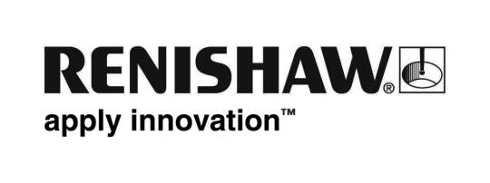
May 2019 Enquiries: Chris Pockett, Head of Communications (+44 1453 524133)

Security, traceability and control in additive manufacturing at RAPID + TCT
To showcase how its customers can keep their additive manufacturing (AM) part data secure, global engineering technologies company, Renishaw, is showcasing its work with Identify3D at RAPID + TCT, North America’s most influential AM event. From the 21st to 23rd of May 2019 at the Cobo Center in Detroit, Michigan, USA, visitors to RAPID + TCT can see demonstrations of Identify3D’s software encryption package on booths 827 and 1459.

Since 2017, Renishaw has been working with Identify3D on implementing their digital supply chain solution to develop an end-to-end secure digital AM process. This means that users of Renishaw’s metal AM systems will be able to secure all part data, protect their intellectual property, enforce production rules and access complete traceability records.

Renishaw’s work with Identify3D aims to ensure integrity throughout the digital supply chain, which is essential for quality assurance (QA), quality control (QC) and historical reporting. This offers major benefits for the aerospace, defence, power generation, automotive and medical industries, and will help broaden the industrial use of AM.

“As metal AM grows and matures, we are seeing an increased requirement to move models, part design know-how, printer files, manufacturing rules and large data — particularly machine sensor and QA/QC data — around our customers’ supply chains,” explained Stephen Anderson, Additive Manufacturing Business Development Manager at Renishaw Inc. “As a consequence, the secure and efficient digital transmission of such files becomes ever more important to ensure that security and data integrity are maintained.”

“Renishaw’s core background is in measurement products for industrial process control and the company is also a leading manufacturer of 3D metal printers. This unique position means that Renishaw understands the complexities of moving data through a production process involving end-users, original equipment manufacturers (OEMs), suppliers and third-party contractors,” added Anderson.

“Following our pilot projects, Identify3D’s software solution can now be implemented with Renishaw AM machines,” explained Fabrizio De Pasquale, VP Business Development and Strategic Accounts at Identify3D. “Because the data package can define the machine parameters, a part can be manufactured repeatably according to initial certification, independent of location and time. For example, manufacturers will now be able to distribute the production of spare parts, moving machines closer to the point of use, rather than transporting and storing a part long distances.”

“The solution is also completely secure – only the authorized machine can unencrypt the data and apply the rules that define how it can be used,” added De Pasquale. “The restrictions placed on what the manufacturer can do with the data provides a strong layer of security. For example, it provides an expiry date and a limit on the number of parts that can be made.”

Identify3D is also exhibiting at RAPID + TCT and can be found on booth 1459. For more information about Renishaw’s AM systems visit www.renishaw.com/additive.

Ends 475 words
Notes to editors
UK-based Renishaw is a world leading engineering technologies company, supplying products used for applications as diverse as jet engine and wind turbine manufacture, through to dentistry and brain surgery. It has over 4,500 employees located in the 36 countries where it has wholly owned subsidiary operations.

For the year ended June 2018 Renishaw recorded sales of £611.5 million of which 95% was due to exports. The company’s largest markets are China, the USA, Germany and Japan.

Throughout its history Renishaw has made a significant commitment to research and development, with historically between 13 and 18% of annual sales invested in R&D and engineering. The majority of this R&D and manufacturing of the company’s products is carried out in the UK.

The Company’s success has been recognised with numerous international awards, including eighteen Queen’s Awards recognising achievements in technology, export and innovation.

Further information at www.renishaw.com

