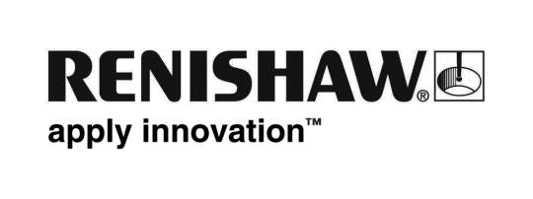
September 2018 Enquiries: Chris Pockett, Head of Communications +44 (0)1453 524133

Renishaw reduces dental framework build preparation time by up to 75 per cent
Global engineering company Renishaw offers QuantAM Dental software which automates additive manufacturing (AM) build preparation for hundreds of dental frameworks in a single operation. The software, which was launched in March 2017, can cut preparation time from two hours or more with existing build preparation software to around 30 minutes. The 75 per cent reduction allows dental production facilities to produce patient-specific frameworks with a reduced workload for staff, enabling cost reductions.

Dental production facilities typically receive hundreds of custom design files daily from multiple customers. Previously, the industry lacked a single suite of software that could handle all the operations required to prepare files for production. Instead, manufacturers were forced to use multiple software applications to prepare for a build.
“QuantAM Dental consolidates the number of software packages required to produce batches of frameworks, helping to reduce licensing overheads, decrease training requirements and reduce build preparation times daily”, explained Ed Littlewood, Marketing Manager at Renishaw’s Medical and Dental Products Division.
“Being able to start builds later in the working day allows more time for designs to be received from customers, leading to a fuller build plate and better production efficiency, whilst still allowing the build to complete before to the next working day.”
QuantAM Dental automatically imports hundreds of dental frameworks, repairs the stereolithography (.stl) files, if necessary and automates the orientation so that framework cavities face upwards, avoiding supports on the fitting surfaces. It also automatically adds an identification tag to each framework to allow reconciliation to designs and finally generates supports.
The software then groups framework types according to manufacturing requirements. For example, frameworks that require heat treatment, such as bridges, are grouped separately from those that do not. Frameworks not requiring heat treatment can quickly and easily be identified before that step in the process is completed.
Finally, QuantAM Dental reviews the files and gives a list of potential errors for any sub-optimal frameworks. The systems operator can then slice the build files ready to transfer them to the AM system. For more information about QuantAM Dental and to see how quick and easy it is to use, watch the video and visit http://www.renishaw.com/dental.

Ends 371 words
Notes to editors
UK-based Renishaw is a world leading engineering technologies company, supplying products used for applications as diverse as jet engine and wind turbine manufacture, through to dentistry and brain surgery. It has over 4,500 employees located in the 36 countries where it has wholly owned subsidiary operations.

For the year ended June 2018 Renishaw recorded sales of £611.5 million of which 95% was due to exports. The company’s largest markets are China, the USA, Germany and Japan.

Throughout its history Renishaw has made a significant commitment to research and development, with historically between 13 and 18% of annual sales invested in R&D and engineering. The majority of this R&D and manufacturing of the company’s products is carried out in the UK.

The Company’s success has been recognised with numerous international awards, including eighteen Queen’s Awards recognising achievements in technology, export and innovation.

Further information at www.renishaw.com

