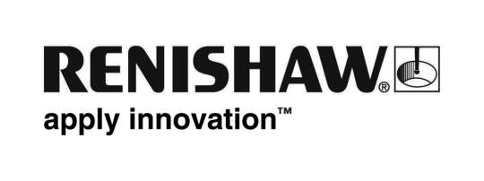
May 2018 Enquiries: Chris Pockett, Head of Communications +44 (0)1453 524133

Renishaw’s integrated neurosurgery solution cleared for sale in USA

The Food and Drug Administration (FDA) has recently cleared the use of Renishaw’s neuromate® Gen III surgical robot with the neuroinspire™ surgical planning software in the USA. Both were previously cleared for use separately, but not in combination ─ This latest clearance means that neurosurgeons across America will now be able to deliver surgical plans created using neuroinspire software directly using the neuromate surgical robot, helping to improve patient outcomes.

Renishaw’s neuromate robotic system for stereotactic neurosurgery provides a platform solution for several functional neurosurgical procedures. The neuromate robot has been used in thousands of procedures such as deep brain stimulation (DBS), stereoelectroencephalography (SEEG), biopsy and more.

The neuroinspire software assists with the planning of stereotactic procedures. Using 3D patient scan data, neuroinspire software allows neurosurgeons to clearly visualise the safest surgical route to target. The software also allows neurosurgeons to visualise an image of implantable instruments in position along with a customisable safety zone.

Before obtaining this latest clearance, plans generated using neuroinspire software could be manually transferred onto a traditional stereotactic frame. With this latest clearance, customers can now export surgical plans from neuroinspire software directly to the neuromate robot for efficient procedure execution.

“Hospitals in the UK and the rest of Europe are already using the neuromate surgical robot in combination with neuroinspire software,” explained Andrew Dissington, Senior Project Manager at Renishaw. “Now, patients across the US will be able to benefit from improved neuromate robot procedures for Parkinson’s, epilepsy and brain tumours.
“SEEG procedures for epilepsy can involve 20 electrodes being implanted into the brain,” added Dissington. “Robotic surgery is much quicker to deliver than manually using a frame. The approval means that existing neuromate surgical robot users are able to take advantage of Renishaw’s intuitive, user-friendly software package.”
Renishaw offers a complete package from planning to delivery, which includes the supply of consumables and training. The company regularly updates its software offering, which can also be customised to meet specific needs using add-on modules.
For more information on Renishaw’s products for stereotactic neurosurgery, visit www.renishaw.com/neuro.
Ends 349 words
Notes to editors
UK-based Renishaw is a world leading engineering technologies company, supplying products used for applications as diverse as jet engine and wind turbine manufacture, through to dentistry and brain surgery. It has over 4,500 employees located in the 35 countries where it has wholly owned subsidiary operations.

For the year ended June 2017 Renishaw recorded sales of £536.8 million of which 95% was due to exports. The company’s largest markets are China, the USA, Japan and Germany.

Throughout its history Renishaw has made a significant commitment to research and development, with historically between 14 and 18% of annual sales invested in R&D and engineering. The majority of this R&D and manufacturing of the company’s products is carried out in the UK.

The Company’s success has been recognised with numerous international awards, including eighteen Queen’s Awards recognising achievements in technology, export and innovation.

Further information at www.renishaw.com

