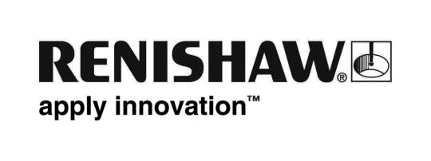
July 2019 Enquiries: Chris Pockett, Head of Communications (+44 1453 524133)

Renishaw supports Girls into Technology event
Global engineering technologies company, Renishaw, ran two workshops at a Girls into Technology event held at SGS Berkeley Green UTC, a university technical college in Gloucestershire, UK. Hosted collaboratively by several employer partners, the event showcased the technology industry to girls aged 12 to 14 and outlined the large variety of careers available in science, technology, engineering and maths (STEM).

Alongside Renishaw, the event was supported by Atkins, Airbus, Cybersecurity Associates, Deloitte and GE Aviation. The attendees, who were from Gloucestershire schools, took part in workshops hosted by the employers, to get a feel for engineering and technology.

Renishaw’s workshops began with a presentation which introduced the company and included a video where some of its female employees spoke about their career experiences. Some of the company’s STEM ambassadors also ran a mini science show which incorporated several exhibits around magnetics and then finished off the workshop by conducting a hands-on engineering activity. One of Renishaw’s female engineers, Rosie Broxton, also gave a talk on her own journey into engineering:

“Young people often feel under pressure to know exactly what they want to do when they are older,” explained Broxton, a Development Engineer at Renishaw. “During my talk, I shared my engineering journey with the girls because it is reassuring for them to hear from someone they can relate to.

“It is important that young people have role models to look up to when choosing a career,” added Broxton. “I was lucky to have had encouragement from STEM teachers and contact with employers as part of the Engineering Education Scheme. By sharing my journey, I was able to act as a role model and inspire the girls, just as I was inspired when I was younger.”

“Renishaw supports events like this to help to increase the number of young people — particularly girls ― choosing STEM careers,” explained Rebecca Bound, Education Outreach Officer at Renishaw. “Practical workshops are a great way for participants to find out for themselves that engineering is fun and that a future career in engineering is fulfilling and exciting.”

Renishaw is committed to bringing clear and positive messages about engineering into schools and colleges throughout Gloucestershire, Bristol and South Wales using its education outreach programme. To find out more about the educational opportunities at Renishaw for local schools visit www.renishaw.com/educationoutreach.

Ends 386 words
Notes to editors
UK-based Renishaw is a world leading engineering technologies company, supplying products used for applications as diverse as jet engine and wind turbine manufacture, through to dentistry and brain surgery. It has over 4,500 employees located in the 36 countries where it has wholly owned subsidiary operations.

For the year ended June 2018 Renishaw recorded sales of £611.5 million of which 95% was due to exports. The company’s largest markets are China, the USA, Germany and Japan.

Throughout its history Renishaw has made a significant commitment to research and development, with historically between 13 and 18% of annual sales invested in R&D and engineering. The majority of this R&D and manufacturing of the company’s products is carried out in the UK.

The Company’s success has been recognised with numerous international awards, including eighteen Queen’s Awards recognising achievements in technology, export and innovation.

Further information at www.renishaw.com

