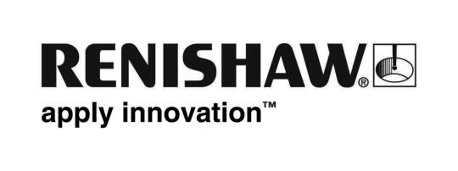
September 2017 Enquiries: Chris Pockett, Head of Communications (+44 1453 524133)

Formula Student success for Renishaw sponsored team

The Cardiff Racing team, from Cardiff University, was recently crowned the first ever UK winners of Formula Student. As part of the annual competition, the team of 56 student engineers designed, built and raced a single seat racing car, beating competition from over 130 university teams from across the globe. Global engineering company, Renishaw, is a sponsor of the team, offering financial and manufacturing aid and advice.
Formula Student, which has existed for over 20 years, is Europe’s most established educational motorsport competition, run in the UK by the Institution of Mechanical Engineers (IMechE). Throughout the year, teams design, build and test a combustion or electric car in competition specifications. Students from all over the world then participate in a four-day event at Silverstone, UK.
At Silverstone, the cars are judged by industry experts during static and dynamic events. Judges award the teams points for a Dragon’s Den style business presentation, a design event and a cost event. The cars are also marked for their dynamic performance in acceleration, handling, endurance and sprint events, in a series of time trial races.
Renishaw has been a sponsor of Cardiff Racing for several years. This year, the company produced some parts for the engine’s intake runners using metal additive manufacturing (AM). Renishaw also presented a talk on AM, guiding the young engineers on how best to design for additive manufacturing, a rapidly growing technology in the automotive sector.
“I got involved in Cardiff Racing during my first year at University and went on to lead the team last year,” explained Sean Creed, Graduate Mechanical Engineer at Renishaw and former Cardiff Racing team leader. “Working with industry partners is essential for Formula Student, as without them, it wouldn’t exist.
“It is useful to meet industry partners to gain an introduction to the company and the wider world of engineering outside of the academic perspective,” continued Creed. “Former members of the Cardiff team have gone on to work for Formula One and other engineering firms, like Renishaw.”
“Renishaw supports a number of projects that develop the skills and experience of budding engineers,” explained Chris Pockett, Head of Communications at Renishaw. “Formula Student acts as a gateway to engineering careers and helps to bridge the gap between industry and academia. Congratulations to the team on this historic win, it is an incredible achievement that demonstrates hard work, skill and passion.”
For more information on Renishaw visit www.renishaw.com.
Ends 386 words
Notes to editors
UK-based Renishaw is a world leading engineering technologies company, supplying products used for applications as diverse as jet engine and wind turbine manufacture, through to dentistry and brain surgery. It has over 4,000 employees located in the 35 countries where it has wholly owned subsidiary operations.

For the year ended June 2017 Renishaw recorded sales of £536.8 million of which 95% was due to exports. The company’s largest markets are China, the USA, Japan and Germany.

Throughout its history Renishaw has made a significant commitment to research and development, with historically between 14 and 18% of annual sales invested in R&D and engineering. The majority of this R&D and manufacturing of the company’s products is carried out in the UK.

The Company’s success has been recognised with numerous international awards, including eighteen Queen’s Awards recognising achievements in technology, export and innovation.

Renishaw is listed on the London Stock Exchange (LSE:RSW) where it is a constituent of the FTSE 250, with a current valuation of around £1.8 billion.

Further information at www.renishaw.com

