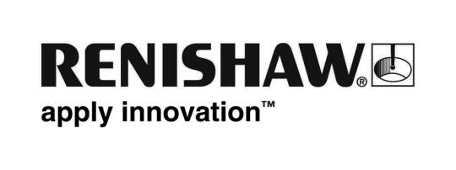
June 2018 Enquiries: Chris Pockett, Head of Communications (+44 1453 524133)

Renishaw promotes productivity at Additive International summit
To share its knowledge and expertise in metal additive manufacturing as a serialised production technique, global engineering company Renishaw is attending the Additive International summit. The event is taking place at the Belfry Hotel, Nottingham, UK from the 10th to the 12th July 2018. It brings together delegates from industry and academia to share knowledge and ideas in the additive manufacturing industry.

Renishaw is a regular attendee at the Additive International summit and this year is a Bronze Sponsor of the event. During the two-day conference, Renishaw’s applications engineers will be available on the stand during breakout sessions to answer delegates’ specific questions.

At the summit, Renishaw will highlight its developments in multi-laser additive manufacturing technology by exhibiting a mobile demo version of its latest additive manufacturing system, the RenAM 500Q. The system features four 500 W lasers to greatly improve productivity in the most commonly used platform size. The competitively positioned machine reduces cost per part, without compromising on quality.

“Multi-laser platforms offer an opportunity for manufacturers to increase productivity,” explained Marc Saunders, Director of Global Solutions Centres at Renishaw. “During the event, we hope to educate professionals and share the capabilities of multi-laser systems to help the industry improve its processes.

“The UK’s Additive Manufacturing Strategy has identified the business opportunity of £3.5bn per year and 60,000 associated jobs,” continued Saunders. “For this to happen, industry must grow, develop and learn how to make the most out of the technology. Such information can be difficult to come by, but the Additive International summit provides a platform for knowledge transfer, which is unique in the UK.”

To support the development of the industry Renishaw operates a global network of Solutions Centres. At the Centres, manufacturers can gain knowledge and confidence in additive manufacturing, accessing Renishaw’s equipment and expertise.

For more information on Renishaw’s additive manufacturing products and services, visit http://www.renishaw.com/en/additive-manufacturing-systems--15239.

Ends 319 words
Notes to editors
UK-based Renishaw is a world leading engineering technologies company, supplying products used for applications as diverse as jet engine and wind turbine manufacture, through to dentistry and brain surgery. It has over 4,500 employees located in the 35 countries where it has wholly owned subsidiary operations.

For the year ended June 2017 Renishaw recorded sales of £536.8 million of which 95% was due to exports. The company’s largest markets are China, the USA, Japan and Germany.

Throughout its history Renishaw has made a significant commitment to research and development, with historically between 14 and 18% of annual sales invested in R&D and engineering. The majority of this R&D and manufacturing of the company’s products is carried out in the UK.

The Company’s success has been recognised with numerous international awards, including eighteen Queen’s Awards recognising achievements in technology, export and innovation.

Further information at www.renishaw.com

