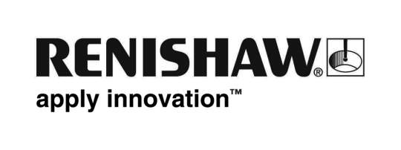
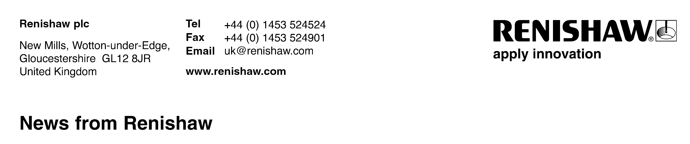
24th November 2008 – for immediate release

Renishaw acquires a 75% interest in Schaerer Mayfield NeuroMate AG and gains a solid foothold in the robot assisted neurosurgery market
As part of its continuing commitment to growing its presence in the neurosurgical market, Renishaw has acquired, for a cash consideration, a 75% stake in Schaerer Mayfield NeuroMate AG, based in Switzerland, and its wholly-owned subsidiary, Schaerer Mayfield NeuroMate Sarl, a leading manufacturer of surgical robots for neurosurgery, based in Lyon, France. The deal was completed on 20th November 2008.

The NeuroMate® image-guided surgical robot has been developed and manufactured by an expert team in Silicon Valley, USA and Lyon, France. To date the robot has been used in thousands of neurosurgical procedures including Deep Brain Stimulation (DBS), Motor Cortex Stimulation (MCS), Stereo Electro-Encephalography (SEEG), neuro-endoscopy, radio-surgery, biopsy, and Transcranial Magnetic Stimulation (TMS). It is the world’s only such robot with both the United States Food and Drug Authority (FDA) approval and European CE mark for stereotactic neurosurgery, and CE mark for neuro-endoscopy applications.

The growth of precision-guided neurosurgery is set to drive further growth in the robot-assisted surgery market. As demands for increased accuracy, safety and efficiencies are required and clinical needs continue to multiply, the prospect of expanding the success of NeuroMate® in France, where there is a proven installed base, to other markets, represents a great opportunity.

Renishaw’s existing neurological portfolio and investment plans in its stereotactic product range, combined with its commitment to this new technology, will enable it to shape this significant market opportunity providing neurosurgeons with improved clinical outcomes and overall efficiency.

Renishaw is already involved in cutting-edge drug delivery activities and neurosurgical planning enhancement technologies. The acquisition of Schaerer Mayfield NeuroMate and robotic expertise will provide a platform technology for these activities, advance the use of functional neurosurgical procedures and reduce clinical complication rates in existing stereotactic procedures, using the only FDA and CE approved neurosurgical robot presently available.

Commenting,

Sir David McMurtry, Renishaw’s Chairman and Chief Executive, said “This investment is an important step for Renishaw, Schaerer Mayfield NeuroMate and surgical robotics more generally. The combination of the pre-eminent stereotactic robot and the portfolio of neurological products that Renishaw is developing based on its precision engineering capabilities, will provide the neurosurgeon with the tools necessary for precise placement of current and next generation therapeutic delivery devices.” ; and

Professor Steven Gill, Consultant Neurosurgeon at Frenchay Hospital, Bristol, UK, and international authority in functional neurosurgery, said, “The combined capability of accurate image-guided planning and the precision delivery that the robot can provide will lead to a major advance in neurosurgery.”
-Ends-
About Renishaw plc
One of the world's leading engineering technology companies, Renishaw, based in the UK, specialises in the design, manufacture and sale of precision metrology and inspection equipment, which is sold to a broad range of industrial sectors. Renishaw plc has been honoured with twelve Queen’s Awards to date, recognising Technological Achievement, Export Achievement and, most recently in April 2007, for Enterprise in the Innovations category.

In the year to 30th June 2008, Renishaw generated revenue of £201.2 million, of which in excess of 90 per cent was to overseas customers, and profit before tax of £41.7 million. The Renishaw Group currently has more than 50 locations in 30 countries, with over 2,200 employees.
More information is available at www.renishaw.com

About Schaerer Mayfield NeuroMate
A pioneer in the field of neurosurgical robotics, the Schaerer Mayfield NeuroMate group has extensive expertise in providing robotics-based solutions for many surgical indications that require very high precision for optimal patient outcome. The NeuroMate® robot has a strong installed base, and a strong support network in France and other European countries.
For stock market release
Contact: Ben Taylor, Tel: +44 1453 524 524, Email: ben.taylor@renishaw.com
Contact: Allen Roberts, Tel: +44 1453 524 524, Email: allen.roberts@renishaw.com
Contact: Mathew Stratton, Tel: +44 1453 524 524, Email: mathew.stratton@renishaw.com

For general release
Contact: Dr. George Boukouris, Tel: +44 1453 5246 41, Email: george.boukouris@renishaw.com
Dr Abed Hammoud, Tel +41 79 309 2777, Email: neuro@renishaw.com

