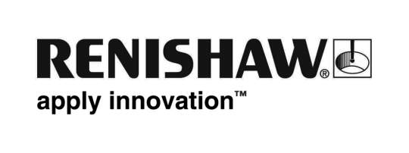

June 2019 Enquiries: Chris Pockett, Head of Communications (+44 1453 524133)

Renishaw’s education outreach team makes Cheltenham Science Festival debut
In June 2019, the education outreach team from Gloucestershire-based global engineering technologies company, Renishaw, attended the Cheltenham Science Festival for the first time. Renishaw was among other science, technology, engineering and maths (STEM) companies who participated in the annual event which aims to inspire the next generation of scientists and engineers.

The festival featured over 200 events and was attended by nearly 10,000 school children and parents
over the six days. Activities on offer ranged from playing with the world’s first gaming robot to building mini jet engines.

Renishaw ran two activities from its stand in the Makershack, an area of the festival dedicated to hands-on workshops. Visitors could cycle on the company’s ‘energy bike’ exhibit, pedalling for 30 seconds to try and produce enough energy to illuminate all the lightbulbs, while also generating enough power to run a fan to cool the cyclist and to charge the battery that powers a display screen and printer; a truly eco-friendly activity. As well as this, Renishaw ran an activity where participants could make a magnetic top chaser where a spinning top chases a paperclip along a table; this activity demonstrates how magnetics, kinetic energy, gyroscopic effect and friction work.

Both activities were among many STEM projects being showcased at the festival and were well-received, with long queues throughout the week. The education outreach stand was supported by a team of Renishaw’s STEM ambassadors, who are primarily young engineers and are great role models for the next generation of scientists and engineers.

“After visiting last year, we quickly realised that the Cheltenham Science Festival was a huge event in the STEM outreach calendar,” explained Rebecca Bound, Education Outreach Officer at Renishaw. “It made good sense for Renishaw to have a presence, as it was a great opportunity to build relationships with additional schools and to increase the number of people with whom we share our educational activities.

“The hands-on environment of the MakerShack played to our strengths,” added Bound. “It was great that we could showcase how much fun science can be using practical activities. The children really enjoyed becoming engineers and making something they could take home to show their friends and family, emphasising that Engineering really is cool!”

The festival also included various presentations, including Neil Armstrong’s son talking about his father on the 50th anniversary of the Apollo moon landing and Alan Turing’s nephew exploring the breaking of the Enigma code. Other activities were held in EDF’s Energy Zone, the GCHQ CyberZone and the Hartpury Science Hub, and careers talks were also held for those interested in entering the world of STEM.

To find out more about the educational opportunities at Renishaw for local schools, or to book a workshop, visit www.renishaw.com/educationoutreach.

Ends 453 words
Notes to editors
UK-based Renishaw is a world leading engineering technologies company, supplying products used for applications as diverse as jet engine and wind turbine manufacture, through to dentistry and brain surgery. It has over 4,500 employees located in the 36 countries where it has wholly owned subsidiary operations.

For the year ended June 2018 Renishaw recorded sales of £611.5 million of which 95% was due to exports. The company’s largest markets are China, the USA, Germany and Japan.

Throughout its history Renishaw has made a significant commitment to research and development, with historically between 13 and 18% of annual sales invested in R&D and engineering. The majority of this R&D and manufacturing of the company’s products is carried out in the UK.

The Company’s success has been recognised with numerous international awards, including eighteen Queen’s Awards recognising achievements in technology, export and innovation.

Further information at www.renishaw.com

