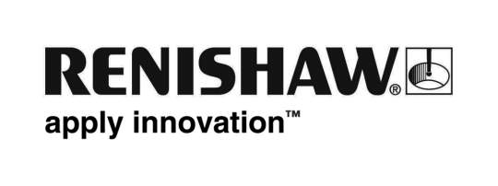
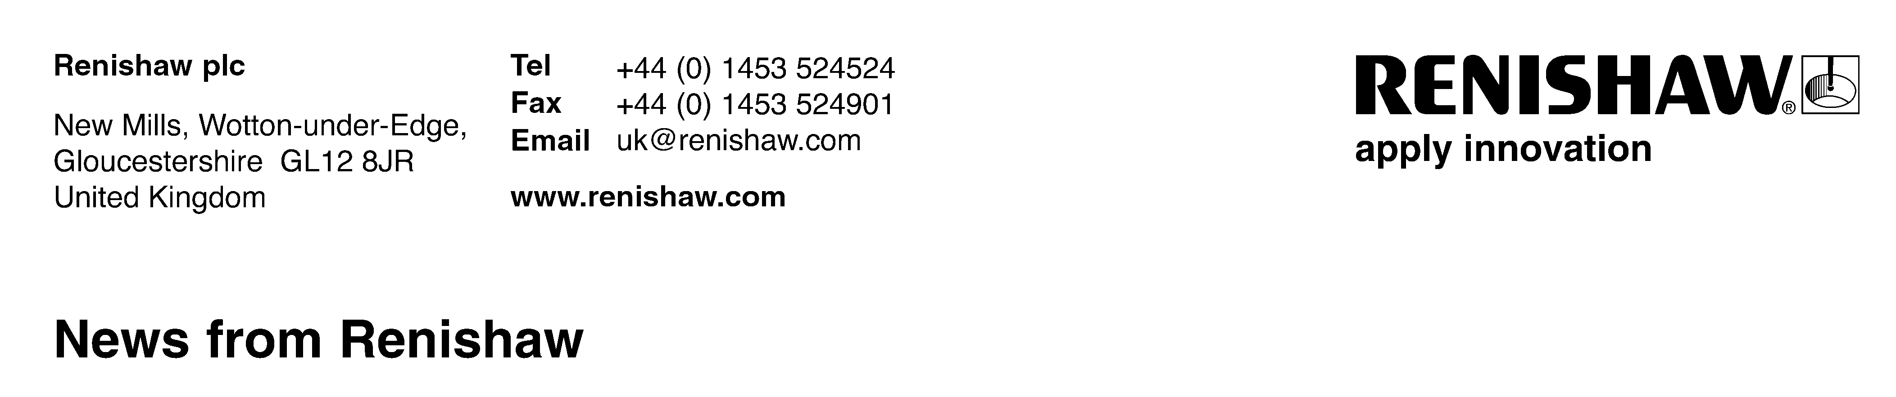
14th May 2009 – for immediate release Enquiries: Chris Pockett (+44 1453 524133)

Renishaw shares knowledge to help UK manufacturers weather the storm

The Manufacturing Advisory Service in the South West (MAS-SW) is advising manufacturers across the UK to work together and share best practice to weather the current economic downturn.

The benefits of this advice were borne out when the region’s top manufacturers attended a MAS national best practice visit, recently hosted by Renishaw, one of the world’s leading engineering technology companies. Held at Renishaw’s head office in Gloucestershire, the event enabled manufacturers to recognise the importance of sharing best practice as well as look at continual improvement and innovation techniques to explore new opportunities.

John Phillipart of MAS-SW said:” Renishaw truly is an exceptional example of a British manufacturing company. The purpose of the event was to help bring manufacturers together and demonstrate how innovation, teamed with efficient manufacturing techniques, can help manufacturers take control of their businesses.”

Marc Saunders, Renishaw’s UK General Manager, said ”We believe that the only way for UK manufacturers to remain globally competitive is by creating high-value added products and services, and by using highly automated production processes. Times are tough, but this is also an opportunity for firms to re-focus their businesses so that they are in good shape to take advantage of a global recovery.”

The event included presentations on new product introduction, continuous process improvement applied to the manufacturing environment, product demos and culminated with a tour of the business.

Marcus Viveash, assistant works manager for Quedgeley-based FLI Structures, which provides a range of towers for the telecommunications industry, said: “The Renishaw best practice event was a real eye opener, demonstrating a very efficient, professional setup.”

For more information or to sign up for the next national best practice event, visit www.mas.berr.gov.uk.
Ends
About Renishaw plc
One of the world's leading engineering technology companies, UK-based Renishaw plc has been honoured with thirteen Queen’s Awards to date, recognising Technological Achievement, Export Achievement and, most recently in April 2009, for Enterprise in the Innovations category.

Renishaw's sensor systems for co-ordinate measuring machines are an industry standard, and its laser and contact probes for CNC machine tools help reduce process waste and variation by automating tool setting, workpiece set-up and workpiece inspection. Other successful product lines include laser calibration systems for machine performance analysis, 3D dental scanning and milling systems, linear and rotary position encoders, Raman spectroscopy systems for spectral analysis of materials, and most recently medical devices for neurosurgical applications.

In the year to 30th June 2008, Renishaw generated turnover of £201.2 million and profit before tax of £41.7 million. The Renishaw Group currently has more than 50 locations in 31 countries, with over 1,800 employees.

More information is available at www.renishaw.com

