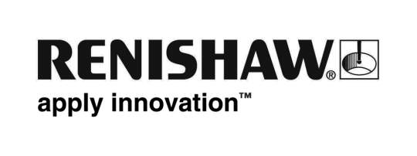
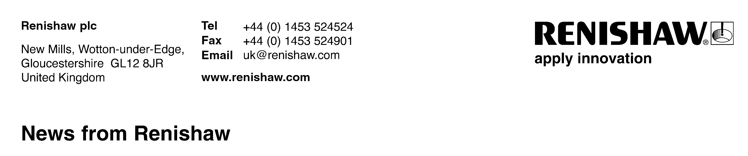
For immediate release Contact: Chris Pockett, Tel: +44 1453 524133

Two metalworking ‘Oscars’ for Renishaw at leading international event
At the prestigious MWP Awards Dinner held in Birmingham, UK, on 8th June, Renishaw plc was honoured with two awards for product excellence. The awards, which are often referred to as the UK metalworking industry’s ‘Oscars’, were achieved against strong competition, with entry open to any worldwide manufacturer with a UK representative.
In the category of 'Best Production Management Software/System', Renishaw’s Productivity+™ and CNC Reporter process control software was judged outright winner, whilst in the category ‘Best Service and Support’, sponsored by Kasto, the company’s CMM Retrofit Service was a joint winner with Haas Automation.
Productivity+ is a PC-based software solution that provides an easy to use platform for creating probing cycles and integrating them into machining programs, whilst CNC Reporter is a simple yet powerful tool for analysing data and creating printable inspection reports from data created with using Productivity+. In their award summary the judges commented, “Now you can embed probing routines into the process – just as you can machine a part, you can check a part.”
The Renishaw CMM (co-ordinate measuring machine) retrofit service, launched in January 2009 and has led to installations of touch-trigger, 3-axis and 5-axis probe systems that transform a machine’s inspection capabilities. Judges commented that “retrofits are breathing life into old CMMs, backed up by remote diagnostics.”
Commenting on the awards, Renishaw’s spokesman, Chris Pockett, said, “The employees who contributed to the development and marketing of these winning products should feel rightly proud of their achievements, especially as both awards were achieved against entries from many other world class suppliers to manufacturing industry.”
Renishaw also sponsored the 'Best Research & Development Project', which was won by ThyssenKrupp Tallent for a collaborative project to develop a Low Stress No Distortion (LSND) welding system for use in an industrial environment. Renishaw’s Chairman & Chief Executive Sir David McMurtry presented the award in front of a 600-strong audience.
Now in their twenty eighth year, the MWP Awards are organised by Metalworking Production Magazine, and are supported by the Manufacturing Technologies Association (MTA). Entries are judged by a panel of nine independent experts from manufacturing industry both practitioners and academics, and includes senior executives from leading organisations such as the AMRC, Siemens, BAE Systems and Rolls-Royce.
Ends

