Innovation provides sustainable competitive advantage in modern manufacturing
Sir David McMurtry, Chairman & Chief Executive, Renishaw plc

Differentiation through innovation


In modern manufacturing markets, where firms are increasingly exposed to global competition, many products have become commodities, even those containing sophisticated technology. Manufacturing excellence is merely a requirement for survival, not a guarantee of long-term success.
Sir David McMurtry, CBE, RDI, CEng, FIMechE, FREng

Throughout its 30-years’ history, Renishaw has pursued a simple and effective business strategy based on innovation. We had the initial good fortune to pioneer a new market sector – touch-trigger probing on co-ordinate measuring machines (CMMs) – and our first products were unique. This allowed us to charge what they were worth to customers, not merely a small mark-up on what they cost us to produce. These healthy margins got the company off to a good start, giving us the profits we needed to expand our sales, marketing and manufacturing facilities to meet growing demand and, importantly, to re-invest in R&D to deliver further innovations.

Success soon gets noticed, however, and our growth could have been quickly snuffed out if a larger company with greater resources had entered our market, reducing prices to commodity levels. Patents, which we vigorously defended, provided us with the space we needed to build a global network of sales, service and support companies, which provided steady year-on-year growth in revenues.

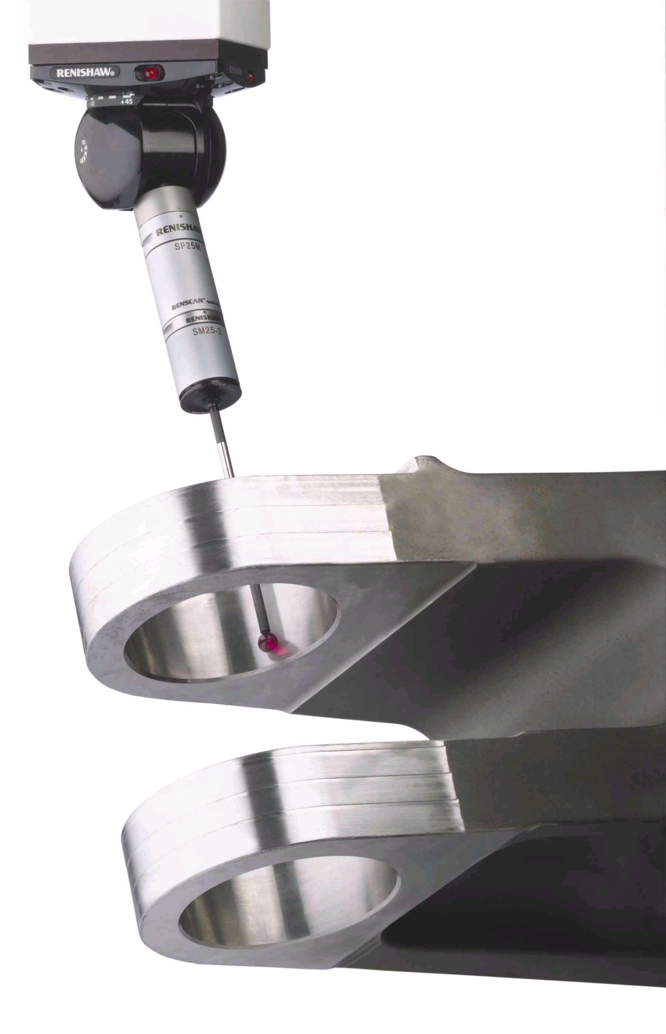
SP25M – the latest probing technology for CMMs

Innovation as a long-term strategy for growth

However, Renishaw’s initial probing product was no ‘one-hit’ wonder. Far from it, for to have stopped at that point would have invited a collapse in revenues and profits once the initial patents expired. The key to Renishaw’s commercial success has been a sustained investment in research and product development, which has provided a stream of innovations. Each successful product provides a flow of margins that fund the development of future products and processes.

Renishaw has applied innovation within its core markets – probing on CMMs and machine tools – to continually regenerate its products to meet the changing demands of its manufacturing customers. Whilst our efforts have not always met with success, there have been enough hits to pay for the misses. As each new generation of products replaces the last, providing higher performance and productivity, we benefit from existing and new customers seeking to further improve their manufacturing processes.
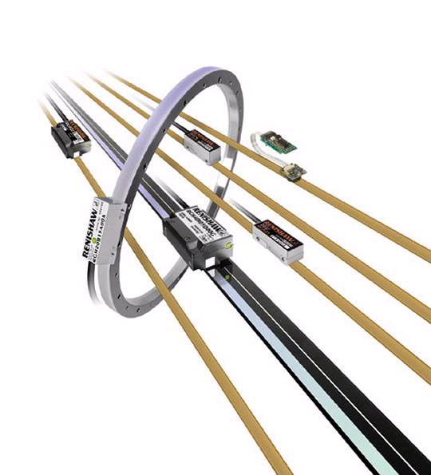
Linear and angular position encoders
Profits from innovative products can fund expansion into new markets and enable a long-term perspective to be taken. A good example of this is our encoder product line, which took more than five years to develop into a profitable business, but which is now a major contributor to current turnover and future growth.

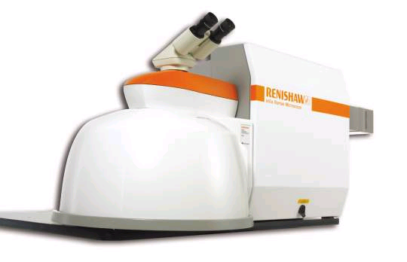
Renishaw is unusual in that we manufacture as many of the components of our products as possible in-house, meaning that process innovation is a vital element of our strategy. This requires regular investment in capital equipment and ongoing development of new machining processes, which ensures that we keep costs on a downward path and that we are in full control of our quality. It also gives us great credibility in our manufacturing markets – it’s easier to promote process improvement when you do it yourself.
InVia Raman microscope

Building the capability to innovate

Innovation cannot insulate a company totally from competition, nor from the business cycle – Renishaw saw its sales fall by 17% in the year to June 2002 as demand in the metal-cutting, electronics and semiconductor sectors contracted. However, it offers the best prospect of underlying growth in turbulent markets. Our organic growth strategy has allowed us to build a business with an annual turnover in excess of £110 million, with no net borrowing and cash resources of over £30 million, whilst returning a profit each year.
Ultra-compact NC4 non-contact laser tool setter

Renishaw’s greatest asset is not the patented products that have come from past R&D investments, it is the people, culture and knowledge – the organisational capability – to produce future innovations. Recognising this, we continue to expand our R&D and engineering investments – more than £20 million last year – the engine that will secure the long-term success and growth of our business.

