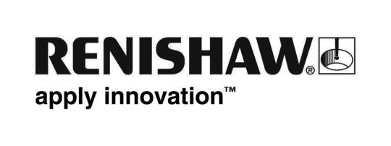
July 2018 Enquiries: Chris Pockett, Head of Communications (+44 1453 524133)

Renishaw raises £4,000 for charity Wrong Trousers Day
On June 29th, 2018, employees at Gloucestershire-based engineering technologies company Renishaw raised over £4,000 for charity by supporting Wrong Trousers Day. On the day, employees ditched their usual workwear in favour of weird and wacky trousers to raise money for The Grand Appeal, the Bristol Children’s Hospital charity. Renishaw is also supporting The Grand Appeal’s Gromit Unleashed 2 trail as a Trailblazer and has designed and manufactured an interactive sculpture for the trail, known as Gromitronic.

Wrong Trousers Day is supported by thousands of schools and businesses across the South West. On June 29th the event was hosted across four Renishaw sites in Gloucestershire; the New Mills headquarters site, Charfield and Woodchester. The team at Wotton Travel, Renishaw’s travel agency on Wotton-Under-Edge high street, also got involved.

On the day employees donated over £2,112, which will be matched by the Charities Committee to make an overall donation of over £4,224. The company has also hosted a bake sale to support the same cause.

To further support The Grand Appeal, Renishaw has produced an interactive character for the charity’s 67-sculpture trail in Bristol, Gromit Unleashed 2. Renishaw has produced one of three moving sculptures, the first in the world in a trail of this kind. Renishaw’s character, Gromitronic, can be found at M Shed in Bristol from Monday July 2nd to Sunday September 2nd, 2018.

“Renishaw’s participation in the event was inspired by our character, Gromitronic,” explained Sarah Plant, Senior Design Engineer at Renishaw’s Encoder Products Division and member of Renishaw’s fundraising committee. “A dedicated team of graduates and apprentices, supported by Principal Engineer Dave Collingwood, were involved in making the sculpture, but we wanted to make the support for the Children’s Hospital company-wide.”

“We had really good take up across our sites,” added Plant. “Renishaw employees were sporting some entertaining outfits. One employee even made the wrong trousers from Wallace and Gromit out of papier mache!”

“Bristol Children’s Hospital is a charity close to the hearts of many of Renishaw’s employees,” explained Chris Pockett, Head of Communications at Renishaw. “Many of our staff have a personal connection with the local hospital, either through family or friends. This year Renishaw has raised over £4,000, an impressive contribution as the region-wide event totalled around £20,000 last year.”

Since 1995, The Grand Appeal has raised over £50 million to support critically ill children and babies. For more information on The Grand Appeal visit https://grandappeal.org.uk. For more information on Renishaw, visit www.renishaw.com.

Ends 405 words
Notes to editors
UK-based Renishaw is a world leading engineering technologies company, supplying products used for applications as diverse as jet engine and wind turbine manufacture, through to dentistry and brain surgery. It has over 4,500 employees located in the 35 countries where it has wholly owned subsidiary operations.

For the year ended June 2017 Renishaw recorded sales of £536.8 million of which 95% was due to exports. The company’s largest markets are China, the USA, Japan and Germany.

Throughout its history Renishaw has made a significant commitment to research and development, with historically between 14 and 18% of annual sales invested in R&D and engineering. The majority of this R&D and manufacturing of the company’s products is carried out in the UK.

The Company’s success has been recognised with numerous international awards, including eighteen Queen’s Awards recognising achievements in technology, export and innovation.

Further information at www.renishaw.com

