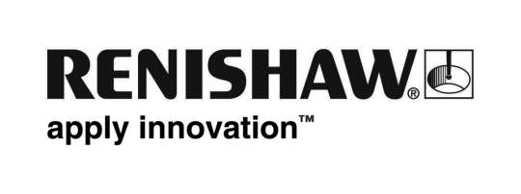
September 2018 Enquiries: Chris Pockett, Head of Communications (+44 1453 524133)

Renishaw employee joins expert panel for international trade
Jenny Iatalese, Trade Control Officer at global engineering company Renishaw, joined the Institute of Export and International Trade’s (IOE&IT) expert panel at the annual South West Summit in Bristol in June, 2018. Iatalese was invited to join the panel following her outstanding results in her World Customs Compliance and Regulations Diploma. At the summit, Iatalese offered advice and support for business leaders with questions about international trade and concerns about the implications of Brexit.

As one of three members of the panel, Iatalese answered the audience’s questions about the challenges related to international trade that she had faced and how she overcame them.

“Nobody knows how Brexit is going to pan out so there is a lot of concern, especially among small and medium sized businesses, about what the implications will be,” explained Iatalese. “The annual summit that the Institute of Export and International Trade runs is a great opportunity for business leaders to gain advice and insight that may help them with decisions they have to make in coming months.

“The organisation also provides a forum with a bank of information and recent news for members, as well as a Helpline Enquiry section for exporters to obtain written advice,” concluded Iatalese.

Iatalese began working on the World Customs Compliance and Regulations Diploma, run by the IOE&IT, in 2016. She completed the course, which was funded by Renishaw, with an award for the highest dissertation grade. Her dissertation was a project to redesign commercial trade documentation so that it is acceptable to many customs jurisdictions worldwide.

As well as appearing on the panel at the South West Summit, Iatalese will be a member of the expert panel that can be contacted by the IOE&IT to reply to requests for advice received via the Helpline Enquiry form. People that contact the IOE&IT with queries related to her specialist area, tariff classifications and free trade agreements, may be referred to her for expert advice and information.

To find out more about Renishaw’s work and contributions in the local area and the wider community, visit www.renishaw.com/corporate-social-responsibility.

Ends 343 words
Notes to editors
UK-based Renishaw is a world leading engineering technologies company, supplying products used for applications as diverse as jet engine and wind turbine manufacture, through to dentistry and brain surgery. It has over 4,500 employees located in the 35 countries where it has wholly owned subsidiary operations.

For the year ended June 2018 Renishaw recorded sales of £611.5 million of which 95% was due to exports. The company’s largest markets are China, the USA, Germany and Japan.

Throughout its history Renishaw has made a significant commitment to research and development, with historically between 13 and 18% of annual sales invested in R&D and engineering. The majority of this R&D and manufacturing of the company’s products is carried out in the UK.

The Company’s success has been recognised with numerous international awards, including eighteen Queen’s Awards recognising achievements in technology, export and innovation.

Further information at http://www.renishaw.com/

