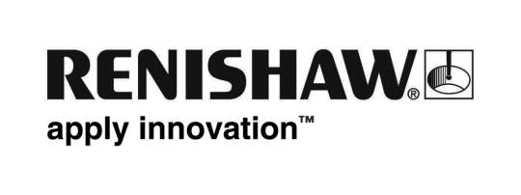
October 2017 Enquiries: Chris Pockett, Head of Communications (+44 1453 524133)

Renishaw takes the lead in productive additive manufacturing

Global engineering and additive manufacturing (AM) technology company, Renishaw, returns to Formnext in 2017, to take the next step in bringing additive manufacturing to mainstream production. From November 14th – 17th in Frankfurt, Germany, the company is exhibiting its latest developments alongside current hardware and software offerings, to unlock the benefits of increased productivity and process monitoring in additive manufacturing. Renishaw can be found in Hall 3.1 on Stand E68.
Renishaw will introduce its new RenAM 500Q four-laser additive manufacturing (AM) system, which significantly improves productivity in the most commonly used machine platform size. Key benefits are a substantial reduction in cost per part whilst maintaining the quality and precision offered by standard single laser systems. By speeding up the process by up to four times Renishaw expects the RenAM 500Q to broaden the market appeal of metal additive manufacturing into applications that are presently uneconomic and potentially into new industries that have yet to embrace AM in production applications.
Visitors to the stand will also be introduced to Renishaw’s AM process monitoring technologies that allow manufacturers to benefit from gathering and analysing sensor data from additive manufacturing systems to develop consistent processing. Fully developed and manufactured in-house, the new process monitoring system combines a chamber camera with synchronous sensing of laser power, galvo position and multi-spectral melt pool sensing. The company will showcase the analytical capabilities of its InfiniAM suite, a process monitoring and production planning tool, which provides feedback on the system sensor data from the AM build. New products on show include InfiniAM Central and InfiniAM Spectral which give users essential information to understand the component build process and monitoring melt pool characteristics in high resolution.
“Multiple laser technology in a small footprint will broaden the appeal of additive manufacturing in new markets and applications,” explained Robin Weston, Marketing Manager at Renishaw’s Additive Manufacturing Products Division. “The technology is moving towards applications where it’s not just the technical benefits of AM that are attractive but also the production economics of using it in a serialised manufacturing process for high quality components.
“At the show, Renishaw will demonstrate to visitors AM’s capabilities as a high quality serialised manufacturing method with good process and quality control,” concluded Weston.
At Formnext, Renishaw will also present High Temperature Build Volume, a new technology that enables manufacturers to build components from materials that are not currently feasible. The technology enables the production of bulkier parts with less risk of thermal stress effects. This has the potential to further expand the capabilities of additive manufacturing and provide a platform for research and development.
Also on the stand will be demonstrations of Renishaw’s next generation automation product ideas, and new features for the company’s QuantAM build preparation software.
For more information on Renishaw visit www.renishaw.com.
Ends 432 words
Notes to editors
UK-based Renishaw is a world leading engineering technologies company, supplying products used for applications as diverse as jet engine and wind turbine manufacture, through to dentistry and brain surgery. It has over 4,000 employees located in the 35 countries where it has wholly owned subsidiary operations.

For the year ended June 2017 Renishaw recorded sales of £536.8 million of which 95% was due to exports. The company’s largest markets are China, the USA, Japan and Germany.

Throughout its history Renishaw has made a significant commitment to research and development, with historically between 14 and 18% of annual sales invested in R&D and engineering. The majority of this R&D and manufacturing of the company’s products is carried out in the UK.

The Company’s success has been recognised with numerous international awards, including eighteen Queen’s Awards recognising achievements in technology, export and innovation.

Further information at www.renishaw.com

