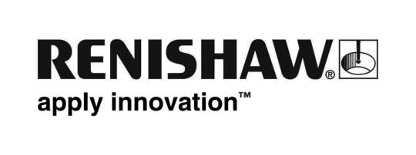
March 2018 Enquiries: Chris Pockett, Head of Communications (+44 1453 524133)

Prestigious award for Renishaw’s Indian software team

At the Maharashtra Information Technology (IT) Awards on February 19th, 2018, global engineering company, Renishaw, was presented with the award for IT Research and Development (R&D) Engineering Services Software. The award was presented in Mumbai by the Chief Minister, Devendra Fadnavis of Maharashtra during the Magnetic Maharashtra Convergence 2018 Global Investors Summit.

The Maharashtra IT Awards promote entrepreneurship in the IT industry across the state, recognising outstanding performance and encouraging the use of IT in society. The event, which was inaugurated by Narendra Modi, the Indian Prime Minister, hosted industry leaders from around the world alongside policy makers from the Indian Government.

Renishaw employs around 400 people in India, operating from five offices, including a manufacturing facility and an Additive Manufacturing Solutions Centre. The company has a team of 140 Software Engineers in India to develop sophisticated and complex software products to complement the company’s metrology, Raman spectroscopy and additive manufacturing hardware offerings.

Renishaw India has played a key role in the development of QuantAM build preparation software for use on Renishaw additive manufacturing systems. The team also contributes to other company software including MODUS and APEX software for metrology applications, WiRE spectroscopy software and the CARTO calibration software suite.

“A large amount of Renishaw’s software work takes place in India,” explained Vikas Saxena, Director and Head of Software at Renishaw India. “Since it was established, the team has gone from strength to strength. India has a very strong software industry, so it is a big achievement for a manufacturing company to win a software focussed award.

“Renishaw produces industry-leading hardware and systems for metrology and additive manufacturing,” continued Vikas. “The team use simulation and abstractions to develop the tools needed to support the company’s product portfolio, an essential part of our operations.”

For more information visit www.renishaw.com.

Ends 301 words
Notes to editors
UK-based Renishaw is a world leading engineering technologies company, supplying products used for applications as diverse as jet engine and wind turbine manufacture, through to dentistry and brain surgery. It has over 4,000 employees located in the 35 countries where it has wholly owned subsidiary operations.

For the year ended June 2017 Renishaw recorded sales of £536.8 million of which 95% was due to exports. The company’s largest markets are China, the USA, Japan and Germany.

Throughout its history Renishaw has made a significant commitment to research and development, with historically between 14 and 18% of annual sales invested in R&D and engineering. The majority of this R&D and manufacturing of the company’s products is carried out in the UK.

The Company’s success has been recognised with numerous international awards, including eighteen Queen’s Awards recognising achievements in technology, export and innovation.

Further information at www.renishaw.com

